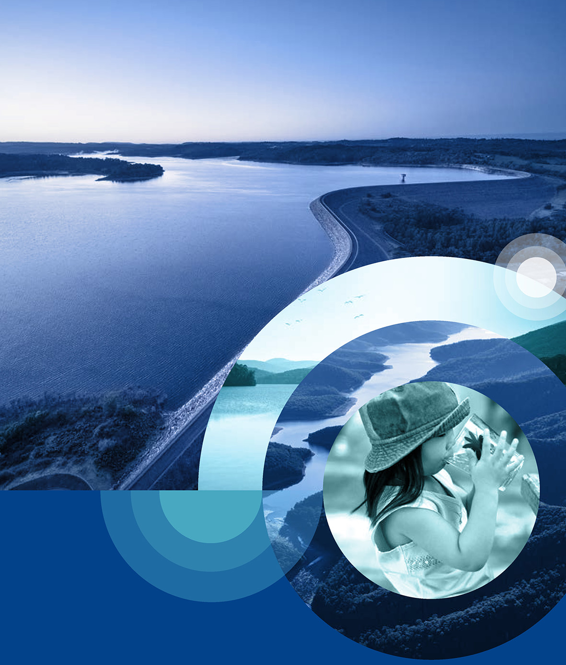

Drinking Water Quality Strategy
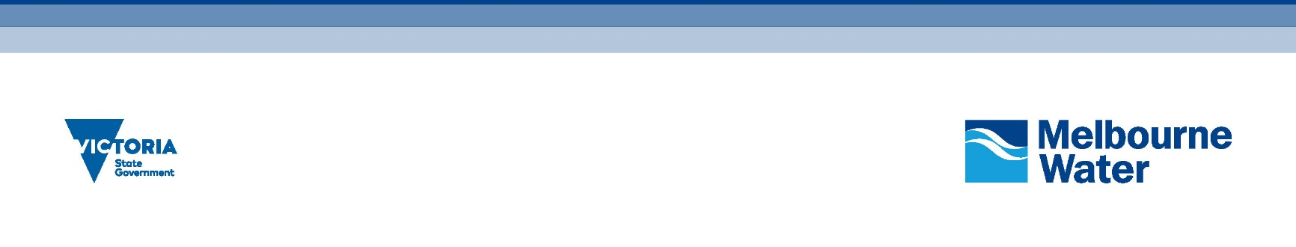

Aboriginal acknowledgement
Melbourne Water proudly acknowledges Aboriginal and Torres Strait Islander people as Australia’s first peoples and the local Traditional Owners as the original custodians of the land and water on which we rely and operate. We pay our deepest respects to their Elders past, present and future. We acknowledge the continued cultural, social and spiritual connections that Aboriginal and Torres Strait Islander people have with the lands and waters and recognise and value that Traditional Owners have cared for and protected them for thousands of generations.
In the spirit of reconciliation, we remain committed to working in partnership with local Traditional Owners and the broader Aboriginal and Torres Strait Islander communities to ensure their ongoing contribution to the future of the water management landscape while maintaining their cultural and spiritual connections.

Foreword
Safe drinking water is essential to making Greater Melbourne a vibrant, liveable, prosperous, and sustainable city both now and in the future. It underpins public health and is central to the trust placed in Melbourne Water by the community. Melbourne Water is committed to discharging our obligations under the Safe Drinking Water Act 2003 and other relevant legislation and regulations to provide safe drinking water to our customers across Greater Melbourne.
We face many challenges in continuing to provide safe, affordable and reliable drinking water. Climate change is driving increasingly extreme operating conditions, while population growth means every day more people rely on the essential services we provide. The ongoing optimisation of our existing water supply system, underpinned by innovation and state of the art scientific knowledge, will enable new ways of delivering our services in the future and ensure we continue to provide services aligned with evolving community expectations. In addressing these challenges and opportunities, we remain deeply committed to environmental sustainability – acting in a way that ensures future generations have the natural resources available to live an equal, if not better, way of life as current generations.
This Drinking Water Quality Strategy outlines Melbourne Water’s strategic approach to continue to deliver safe, affordable, and reliable drinking water to all of our customers over the next 20-50 years and specifies tangible actions over the next five years. This strategy sets out an approach that embraces, maintains, and builds on the achievements and legacy assets of the past while planning approaches and solutions suitable for the future.
This is one of Melbourne Water’s key strategies that collectively outline our contribution to enhancing life and liveability across Melbourne and the surrounding region, implementing the policies described in the Victorian Government’s Central and Gippsland Region Sustainable Water Strategy and guiding our vital contribution to the daily lives of Melburnians through a commitment to healthy people, places, and the environment.
Making our city vibrant, liveable, prosperous, and sustainable was a shared responsibility. During the development of this Drinking Water Quality Strategy, we have valued the input of our customers, the retail and regional water corporations, and other key stakeholders to ensure we set a direction consistent with their needs and expectations. Ongoing collaboration will also be essential to implementing this strategy as a liveable city is built on strong and effective partnerships.

Dr Nerina DiLorenzo
Managing Director


Contents

Foreword 2
Summary 4
Why we need a drinking water quality strategy 4
Our strategic approach 5
How we will know this strategy has been successful 7
A guide to reading this strategy 8
Introduction 9
What is safe drinking water and why is it important? 10
About this strategy 10
Melbourne Water: Enhancing Life and Liveability 12
Our strategic direction 12
Our responsibilities 12
Melbourne’s water supply system 14
Protected catchments 15
Open catchments 15
The Victorian Desalination Project 18
Transfer and storage 18
Our customers 18
Our regulators 19
Traditional Owners 20
Policy directions 20
How this strategy relates to others 20
Planning for an uncertain future 22
Safe, reliable, affordable drinking water in an uncertain future 23
Increasingly extreme operating conditions 23
A growing population with changing expectations 23
Emerging technical water quality challenges 24
Supporting environmental sustainability 25
An integrated approach 26
How we will know this strategy has been successful 27
Strategic goal 1: Continuity of safe supply 28
Strategic goal 2: Source management 34
Strategic goal 3: Trust, innovation and leadership 46
Strategic goal 4: Resilience of safe supply 51
Appendix: Summary of actions 60

Summary
Enhancing life and liveability
Melbourne Water’s strategic direction describes our unique contribution to the vision of ‘Enhancing Life and Liveability’ with three pillars: ‘Healthy People’, ‘Healthy Places’ and ‘Healthy Environment’. This strategy is fundamental to the ‘Healthy People’ pillar and the service experience of our customers. Safe, reliable and affordable drinking water is foundational to life and liveability in Greater Melbourne. Melbourne Water has been providing this essential service for over 130 years.
Melbourne has a safe and trusted water supply system, and the way we provide our service is central to the experience and perceptions retail and regional water corporations have of Melbourne Water. Maintaining leadership in this area requires us to recognise new challenges, commit to innovation and embrace new ways of managing risks and opportunities to Melbourne’s water supply system – from catchment to tap.

Why we need a drinking water quality strategy
This strategy describes how Melbourne Water will continue working collaboratively with retail and regional water corporations, regulators and stakeholders to deliver safe, reliable and affordable drinking water over the next 20 to 50 years. While the focus of this strategy is on parts of the water supply system Melbourne Water manages, we have engaged retail and regional water corporations (our customers) during the development of the strategy to ensure it sets directions that will enable us to effectively and efficiently work together to manage drinking water quality.
Melbourne faces many challenges in terms of water quality such as climate change and variability, extreme events, population growth, urbanisation, changing community expectations, and changing regulatory standards, among many others. However, over the next 20 to 50 years, opportunities will also emerge, such as the ongoing development of treatment technologies that have already enabled manufactured water (desalinated water, recycled water and treated stormwater) to become a key source of water in many cities around the world, including in Melbourne through the Victorian Desalination Project.
This strategy builds on the previous 2017 Drinking Water Quality Strategy, which shaped and enabled significant improvements in drinking water quality risk management over the last five years. This updated strategy outlines an approach that maintains and builds on the achievements and legacy assets of the past while planning approaches and solutions suitable for the future. In line with this approach, effective catchment protection will remain a cornerstone of our approach to managing drinking water quality risks for our existing water supply catchments, but our reliance on sophisticated engineered treatment barriers will grow over time as we necessarily source increasingly large volumes of manufactured water as climate change, a growing population, and other factors drive an evolution in our supply sources.
The Central and Gippsland Region Sustainable Water Strategy indicates that by 2070, in response to these drivers, more than 80 per cent of Greater Melbourne’s water needs could be met by manufactured water.
The application of the multiple barrier approach remains central to this strategy, where we identify and implement opportunities to eliminate or reduce water quality risks at the multiple stages of the water supply process, including through catchment management, water treatment and transfer system hygiene. This strategy also reflects our intent to pursue a catchment to tap approach to managing drinking water quality – for both public health and aesthetic purposes – by strengthening and extending our collaboration with our customers.
Adoption of the microbial health-based target approach, including the tolerable risk target of 1 microDALY per person per year, in the previous 2017 strategy continues to provide a robust process of guiding investment in the most effective and efficient catchment to tap measures to protect public health, consistent with international best practice. This commitment to a rigorous science-driven approach will continue as part of this strategy, driving a substantial optimised investment program over the next few years to ensure the safety of all our water sources.

Our strategic approach
Over the next 20 to 50 years, we face a complex and uncertain set of challenges and opportunities for delivering safe, reliable and affordable drinking water. These are recognised and addressed by four strategic goals and their associated outcomes to be delivered as outlined in Figure 1. As new challenges and opportunities emerge, Melbourne Water will adapt its strategic approach as required, and this strategy will be reviewed every five years. Specific actions to be delivered over the next five years to drive progress towards the four strategic goals are summarised in the Appendix.
Cardinia Reservoir
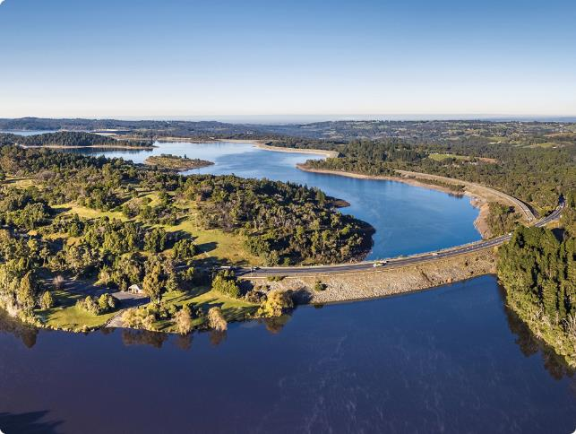
Over the next 20 to 50 years, we face a complex and uncertain set of challenges and opportunities for delivering safe, reliable and affordable drinking water.

Figure 1. Overview of the strategic goals and outcomes described in this strategy.
Strategic Goal | Strategic Outcomes
Continuity of safe supply  We continuously improve our systems, processes, people and infrastructure to enable us to do the basics of drinking water quality risk management brilliantly | - Current and emerging drinking water quality risks are quantified, documented, communicated, and managed proactively and systematically from catchment to tap in partnership with our customers  - Efficient and effective management of drinking water quality risks is delivered by a diligent, capable and knowledgeable workforce  - The value of the existing water supply system is maintained, enhanced and leveraged as we invest to meet future challenges and realise future opportunities
Source management  We take a robust multiple barrier approach to managing drinking water quality risks, ensuring that drinking water from all existing and potential future sources are equally safe | - In protected water supply catchments, drinking water quality risks are managed by chlorine primary disinfection and prudent and efficient investment in bushfire management, unauthorised entry and pest species control programs  - In open water supply catchments, drinking water safety is ensured through an optimised multiple barrier approach balancing catchment management with engineered treatment barriers  - In the Tarago and Yan Yean water supply catchments, a measured approach to additional recreation is supported when community benefits outweigh costs, where risks can be managed to ensure drinking water safety and where costs can be appropriately assigned to beneficiaries  - Drinking water from future water sources is safe through an optimised multiple barrier approach balancing catchment management with engineered treatment barriers, enabled by a mature and consistent risk management framework  - After water treatment, drinking water remains safe as it is transferred to our customers - the retail and regional water corporations
Trust, innovation and leadership  Our customers, stakeholders, and regulators value and trust our leadership and innovation in managing our drinking water supplies | - The expertise and agreed outcomes expected by our regulators, customers and stakeholders are embedded in our approach to managing drinking water quality risks  - Research and monitoring programs build our understanding of water quality issues, identify emerging threats, and provide an evidence base to enable targeted, cost effective and adaptive risk management  - As a learning organisation, we maximise benefits and minimise costs by adopting innovative approaches and new technologies, and by driving continuous improvement across all our activities
Resilience of safe supply  Potential threats are anticipated, and appropriate measures are in place to enable supply to continue during and after extreme events with minimised impacts on customers | - The water supply system, associated supply chains and related infrastructure systems are resilient to defined and agreed extreme event scenarios associated with climate change and other drivers  - Emergency management systems and plans are contemporary and effective, aligned with those of our customers, regulators and stakeholders, and reflect outcomes of regular emergency management training exercises  - Our customers, regulators and stakeholders share our understanding of potential vulnerabilities to extreme events and support investment decisions that reflect community willingness to pay for enhanced resilience

How we will know this strategy has been successful
This strategy will drive the actions summarised in
the Appendix, successful completion of which is one indicator of success. More broadly, the success of this strategy will also be measured by the extent to which we are able to achieve the following three
performance indicators:
- Appropriate catchment management and engineered treatment barriers are in place for all water sources, including to enable routine achievement of 1 microDALY per person per year for microbial risk for all water sources by 2027.
- Regulators and our customers endorse plans for proposed investment related to drinking water quality risk and resilience in the 2026 Price Submission.
- Customer relationship performance indicator scores for the water service between 2022 and 2027 are maintained or improved, as measured through the customer satisfaction by service and customer effort metrics.
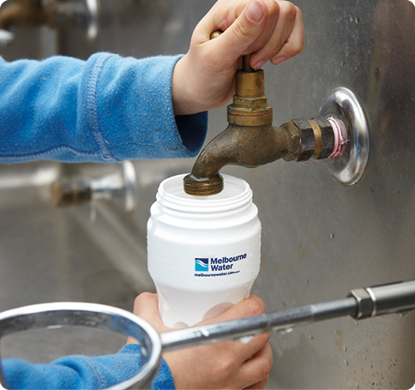

Maroondah Reservoir
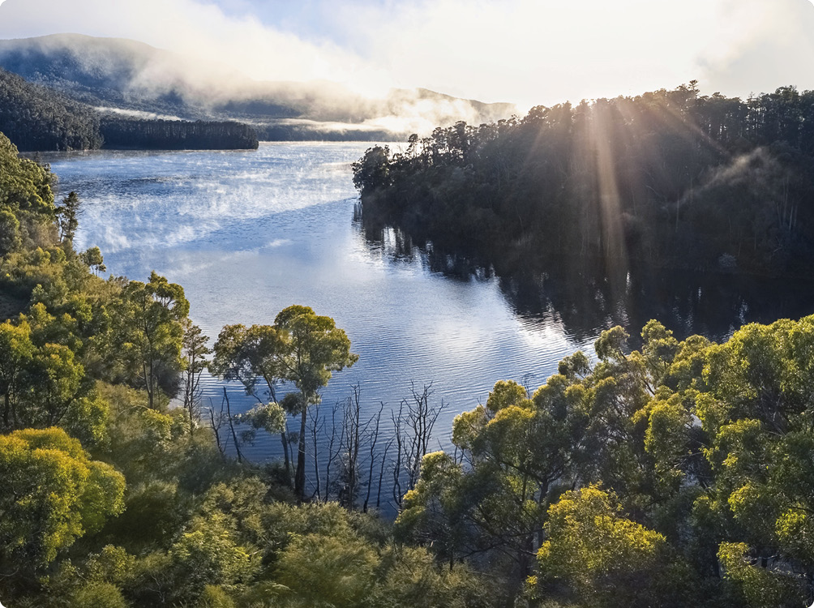

A guide to reading this strategy
This strategy is structured around three key chapters as shown in Figure 2.
Figure 2. Structure and indicative program logic for the Drinking Water Quality Strategy
Drinking Water Quality Strategy
Safe, reliable and affordable drinking water for Greater Melbourne
Context | Challenges | Actions, Strategic outcomes, Strategic goals
Chapter 1 – Introduction  This chapter covers why this strategy is needed, includes a description of Melbourne Water, our customers, and our regulators, and outlines how this strategy links to other elements of our operating environment. | Chapter 2 – Planning for an uncertain future  This chapter introduces the key challenges that relate to this strategy:  - Increasingly extreme operating conditions  - a growing population with changing expectations  - emerging technical water quality challenges, and  - supporting environmental sustainability. | Chapter 3 – An integrated approach  This chapter is structured around four strategic goals, each of which has a number of associated actions that will be delivered over the next five years resulting in strategic outcomes that support progress towards achieving the strategic goals.  The actions generally relate to new or changed activities – unless mentioned in an action, existing and planned drinking water quality management activities will continue unchanged.  The actions and associated strategic outcomes relate to:  - areas where recent reviews, investigations, and other activities have identified opportunities for improvement  - government policy objectives, and/or  - the natural or logical focus areas associated with a particular strategic goal.  The approach is integrated in that each goal, outcome, and action addresses multiple challenges and seeks to enable their management from catchment to tap in partnership with our customers – the retail and regional water corporations.

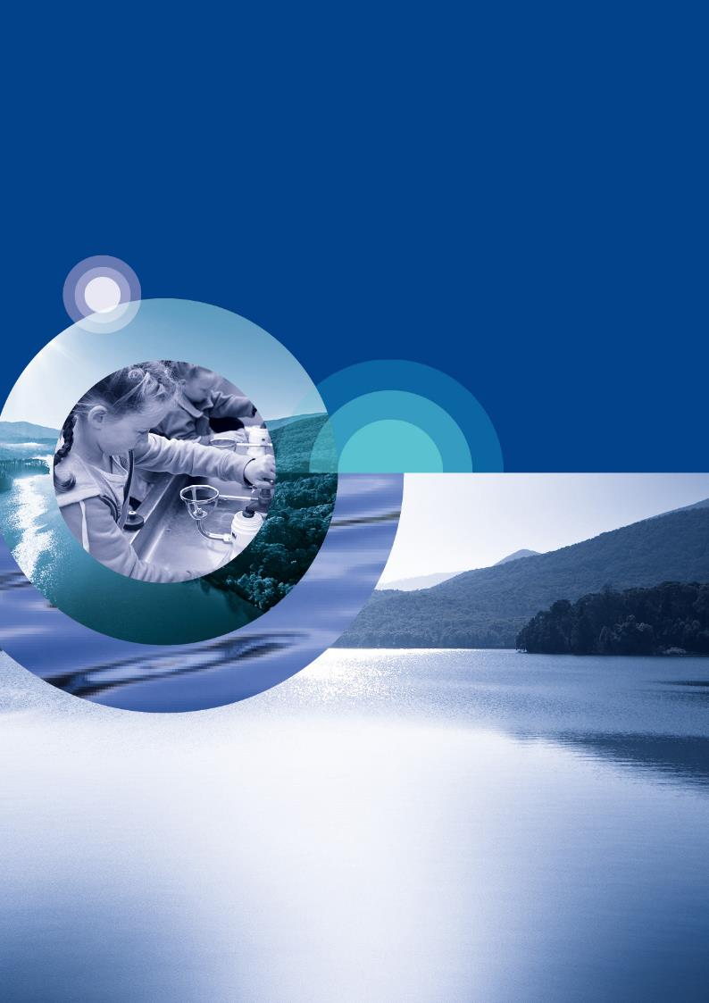
Introduction

What is safe drinking water and why is it important?
Melbourne Water is committed meeting its obligations under the Safe Drinking Water Act 2003 and other relevant legislation and regulations to provide safe drinking water to our customers across Greater Melbourne.
Safe drinking water is essential to health. In 2010 the United Nations General Assembly voted to recognise the right to safe and clean drinking water and sanitation as a human right that is essential for the full enjoyment of life and all human rights. Access to safe drinking water is central to the United Nations Sustainable Development Goals, including specifically as part of Goal 6: Clean Water and Sanitation. Melbourne Water is a signatory to the United Nations Global Compact, the world’s largest corporate sustainability initiative, and we have made a public statement of support for the Sustainable Development Goals.
According to the World Health Organization safe drinking water ‘does not represent any significant risk to health over a lifetime of consumption, including different sensitivities that may occur between life stages.’ The Australian Drinking Water Guidelines note that ‘Drinking water does not need to be absolutely pure to be safe’ but that safe drinking water ‘should contain no harmful concentrations of chemicals or pathogenic microorganisms, and ideally it should be aesthetically pleasing in regard to appearance, taste and odour.’
In 2007 more than 11,000 British Medical Journal readers voted in a poll that the introduction of clean drinking water and sewage disposal was the most important medical milestone since 1840. Before safe drinking water and sewage disposal was introduced in Melbourne, waterborne disease was prevalent – more than 400 of the 9300 deaths in Melbourne in 1890 were caused by typhoid. This is no longer the case in Melbourne, but failures of drinking water quality risk management still have the potential to cause widespread waterborne disease outbreaks.
For example in Milwaukee, USA in 1993, assessments indicate more than 400,000 people became ill with gastrointestinal disease from Cryptosporidium, and premature deaths of at least 69 immunocompromised people were recorded. More recently, in Havelock North, New Zealand in 2016, 45 people were hospitalised and four people died after an unchlorinated drinking water supply was contaminated with Campylobacter originating from faecal material from sheep.
These types of waterborne disease outbreaks are typically driven by a lack of understanding of risk and/or failure to adequately manage risk through an appropriate combination of catchment protection, engineered treatment barriers and distribution system hygiene. This strategy addresses both drivers of historical failures, including how we understand and quantify risk, and how we adequately manage risk. Ensuring waterborne disease outbreaks remain in the distant past builds and maintains confidence and certainty around water quality, and supports community wellbeing, economic growth and the liveability of Greater Melbourne.

About this strategy
This Drinking Water Quality Strategy describes how Melbourne Water will continue to deliver safe, reliable and affordable drinking water to our customers across Greater Melbourne over the coming decades. While the focus of this strategy is on the parts of the water supply system managed by Melbourne Water, we have engaged with our customers during the development of the strategy to ensure it sets directions for effectively and efficiently working together to manage drinking water quality from catchment to tap.
This strategy retains and builds on the previous 2017 Drinking Water Quality Strategy, in which Melbourne Water first adopted the internationally recognised benchmark for safe drinking water – the microbial health-based target of 1 microDALY per person per year. It also reflects new knowledge and observations obtained over the last five years.
What is a DALY?
The Disability Adjusted Life Year or DALY is a metric used widely in public health research and risk management to quantify the burden of disease in the community. The DALY integrates the frequency of infection, severity of disease and duration of impacts into one metric. The term disability refers to a condition that detracts from good health.
DALY = YLL (years of life lost) + YLD (years of life lived with a disability or illness)
1 microDALY is an abbreviated or simplified way of expressing 0.000001 DALY.
As part of developing this strategy, Melbourne Water has engaged widely through a range of different channels and formats, consulting with customers, regulators and stakeholders, and drawing on expert advice from across the water sector.
This strategy is reviewed every five years. It includes an action to explore potential alternative mechanisms for the next review, including considering the preparation of a joint Drinking Water Quality Strategy in partnership with our customers to more holistically reflect the way we manage drinking water quality from catchment to tap.
Impact of the previous Drinking Water Quality Strategy
The previous 2017 Drinking Water Quality Strategy remains highly relevant today and has enabled significant improvements in drinking water quality risk management over the past five years. Supported by the 2017 strategy, and the long history of drinking water quality risk management that preceded it, 84 per cent of Melburnians rated the quality of Melbourne’s drinking water as high or very high in 2022.
The 2017 Drinking Water Quality Strategy was the first in which Melbourne Water adopted the microbial health-based target approach and tolerable risk benchmark of 1 microDALY per person per year. This approach embeds a robust process of guiding investment in the most effective and efficient catchment to tap measures to protect public health. This commitment to a rigorous, science-driven approach has underpinned more than $200 million of planned capital investment during the current 2021-2026 regulatory period on new assets that will support improved drinking water quality risk management.
Key examples include:
- Mt Evelyn water treatment plant, which will further enhance the reliability of disinfection for the majority of water supplied from Silvan Reservoir
- The addition of an ultraviolet disinfection treatment step at the Winneke water treatment plant to ensure water supplied from this source reliably meets our microbial health-based target under a wider range of potential catchment and operating conditions
- Yan Yean water treatment plant upgrade, which will address taste and odour issues for water from this catchment that can cause community concern, and will also add an additional ultraviolet disinfection treatment barrier for protozoa
- Coranderrk Pipeline, which will replace the existing Coranderrk Aqueduct and eliminate drinking water quality and other risks currently associated with the existing open aqueduct system upstream of Silvan Reservoir
- Cardinia Reservoir catch drain upgrade, which will further reduce the risk associated with stormwater runoff from extreme rainfall events impacting the quality of water stored in the reservoir.
In addition to these major capital projects, a number of smaller capital projects and enhancements of operational programs are also being delivered, including critical improvements to the management of potential unauthorised entry to protected catchments.
The process of implementing these key initiatives is well underway and further investigations will identify opportunities for continuous improvement. In this context, it is critical this 2022 strategy builds on its predecessor, reiterating our commitment to a multiple barrier approach and the microbial health- based target of 1 microDALY per person per year.

Melbourne Water: Enhancing Life and Liveability
Melbourne Water makes a vital contribution to Melbourne’s world renowned lifestyle by supporting human health, enhancing community wellbeing, facilitating economic growth and balancing the natural and man-made environment. We are responsible for the supply of affordable, high-quality water, reliable sewerage, healthy waterways and integrated drainage management. Through all that we do, we help make Greater Melbourne a fantastic place to live.

Our strategic direction
Melbourne Water’s strategic direction describes our unique contribution to the vision of ‘Enhancing Life and Liveability’ with three pillars: ‘Healthy People’, ‘Healthy Places’ and ‘Healthy Environment’. This strategy is fundamental to the ‘Healthy People’ pillar and the service experience of our customers. Safe drinking water is foundational to life and liveability in Melbourne.
To guide our role and activities in relation to drinking water quality and other activities that contribute to public health outcomes, Melbourne Water has a Public Health Policy endorsed by our Board of Directors. The Public Health Policy is intended to maximise public health benefits to the community from Melbourne Water’s activities. The Drinking Water Quality Strategy is consistent with our Public Health Policy.

Our responsibilities
As the bulk supplier of Melbourne’s drinking water, Melbourne Water is responsible for managing water sources, treating water derived from those sources and managing water quality in the transfer network while transferring water to defined interface points with our customers, who in turn supply water to over 5 million people in homes and businesses across Greater Melbourne.
Our key legislative obligations related to managing drinking water quality include:
- Provide, manage, operate, maintain and protect the water supply system under the Water Act 1989, and any associated by-laws
- Promote and protect public health and wellbeing with regard to the guiding principles of the Public Health and Wellbeing Act 2008
- Prepare, implement and review a drinking water quality risk management plan under the Safe Drinking Water Act 2003 and associated Safe Drinking Water Regulations 2015
- Manage risk to protect public safety, quality and security of supply under the Statement of Obligations (General) made under the Water Industry Act 1994
- Prepare and monitor implementation of a regional catchment strategy for the Port Phillip and Westernport region, and manage special water supply catchment areas established under the Catchment and Land Protection Act 1994
- Add fluoride to water supplies as directed by the Secretary of the Department of Health under the Health (Fluoridation) Act 1973 and associated Code of Practice for Fluoridation of Drinking Water Supplies
- Manage, operate and protect the water supply system under Security of Critical Infrastructure Act 2018.
In meeting our legislated and regulated obligations outlined above, we take into account Victorian and Commonwealth government policy, the latest scientific knowledge and industry practice, Melbourne Water’s policies, strategies and risk appetite, and the agreed expectations and contractual obligations established with our customers.
Through all that we do, we help make Greater Melbourne a fantastic place to live.
Guidance on industry practice
The Australian Drinking Water Guidelines were released in 1996 and the current edition has been in place since 2011. These guidelines are intended to ‘provide an authoritative reference on what defines safe, good quality water, how it can be achieved and how it can be assured. The Australian Drinking Water Guidelines are not mandatory standards, however, they provide a basis for determining the quality of water to be supplied to consumers in all parts of Australia. These determinations take into account local factors including customer expectations and willingness to pay.’
A key feature of the Australian Drinking Water Guidelines are the six guiding principles:
- The greatest risks to consumers of drinking water are pathogenic microorganisms. Protection of water sources and treatment are of paramount importance and must never be compromised
- The drinking water system must have, and continuously maintain, robust multiple barriers appropriate to the level of potential contamination facing the raw water supply
- Any sudden or extreme change in water quality, flow or environmental conditions (e.g. extreme rainfall or flooding) should arouse suspicion that drinking water might become contaminated
- System operators must be able to respond quickly to adverse monitoring signals
- System operators must maintain a personal sense of responsibility and dedication to providing consumers with safe water and should never ignore a consumer complaint about water quality.
Ensuring drinking water safety and quality requires the application of a considered risk management approach. The Australian Drinking Water Guidelines include an overview of the acceptable microbial, physical and chemical, and radiological characteristics of drinking water for health and aesthetic purposes.
Where the Australian Drinking Water Guidelines do not provide a guideline value for a water quality characteristic, they establish a hierarchy of international references to consult. In many cases the recommended source of supplementary guidance is the World Health Organization Guidelines for Drinking-water Quality. Supplementary guidance on leading industry practice regarding management of microbial risks in drinking water is provided by the Water Services Association of Australia Manual for the Application of Health-Based Targets for Drinking Water Safety.
Sugarloaf Reservoir
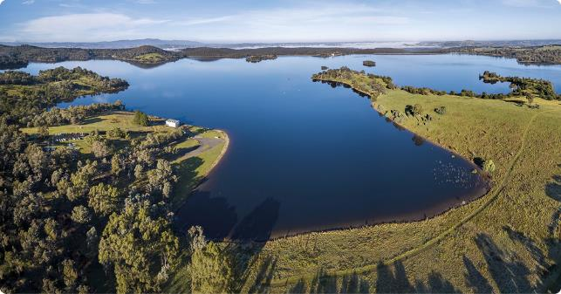

Melbourne’s water supply system
Melbourne Water manages more than 1075 kilometres of pipelines, 213 kilometres of aqueduct systems, 11 major untreated water storage reservoirs, 63 treated water service reservoirs and 15 operational primary water treatment plants. We also work with catchment management delivery partners and stakeholders across nearly 300,000 hectares of protected and open water supply catchments. These assets are shown in Figure 3. Currently, the sources of drinking water used in Melbourne are protected and open surface water catchments, and the Victorian Desalination Project.
Figure 3. Melbourne water supply system
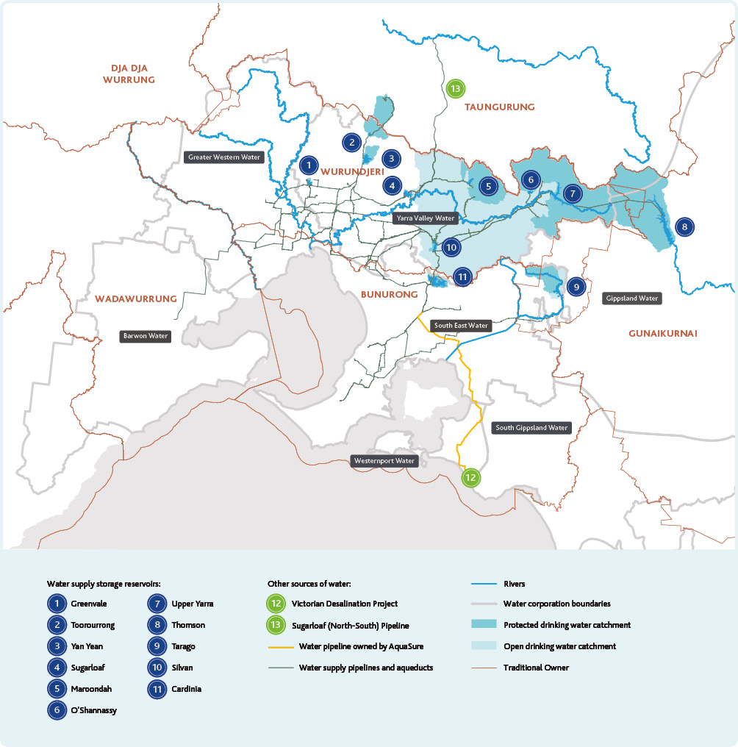

Protected catchments
Almost 150,000 hectares of the water supply catchments we currently harvest water from are protected and forested, with only very limited human access and activities allowed. These catchments are mainly managed by the Department of Energy, Environment and Climate Action (DEECA) (state forests) and Parks Victoria (national parks), while Melbourne Water manages some much smaller areas of freehold land we own and Crown Land vested in Melbourne Water.
Across these catchments there are a range of types and levels of protection in place, from fully fenced catchments closer to the city that are regularly patrolled by security guards, through to other more remote catchments where some limited public access is allowed on specified roads and walking trails. In national parks, there is specific provision for the maintenance of the water quality and otherwise for the protection of the water resources under the National Parks Act 1975. The O’Shannassy Reservoir and Wallaby Creek catchments are also protected as natural catchment areas under the Heritage Rivers Act 1992. In state forests there are protections established under the Catchment and Land Protection Act 1994 and Forests Act 1958. For infrastructure assets and land owned or managed by Melbourne Water, the Water Act 1989 enables us to prohibit public access.
Almost 150,000 hectares of the water supply catchments we currently harvest water from are protected and forested, with only very limited human access and activities allowed.
Most of the water we source from protected catchments in the Yarra and Baw Baw Ranges is supplied to our customers from Silvan, Cardinia and Greenvale Reservoirs, with a limited volume supplied through a number of much smaller treatment plants to towns throughout the Yarra Valley. Water from our protected catchments generally requires very minimal treatment to make it safe and pleasant to drink. The key treatment processes we use for these catchments are chlorination (disinfection), fluoridation (for the vast majority of water we supply), and pH adjustment. On average, more than 65 per cent of the water we supply is treated in this way.
Water supplied from Yan Yean Reservoir and to Healesville and Yarra Glen (from Coranderrk Creek, Grace Burn, and Maroondah Reservoir) is also filtered to manage colour, turbidity and specific microbial risks from these sources.

Open catchments
Other catchments, including the mid-Yarra catchment and part of the Tarago River catchment, are unprotected – or open – with few limitations on human access and activities. These open catchments comprise nearly 50 per cent of the total catchment area across our water supply system.
In the mid-Yarra catchment, which extends from Upper Yarra Reservoir down to Yering Gorge, there are a range of residential, industrial, agricultural and tourism land uses. Water from this catchment is mixed in Sugarloaf Reservoir with water from the protected Maroondah Reservoir catchment, before being treated at the Winneke water treatment plant which was built in 1980. The North-South Pipeline, formerly known as Sugarloaf Pipeline, is a 70 kilometre pipeline that can carry water from the open Goulburn River catchment to Sugarloaf Reservoir. It is not currently operating and can only be used when Melbourne’s water storages are extremely low, or when needed for local firefighting along the length of the pipeline.
In the east branch of the Tarago River catchment, there are rural residential and agricultural land uses. Water from this catchment is mixed in Tarago Reservoir with water from the limited access west branch of the Tarago River catchment, before being treated at the Tarago water treatment plant which was built in 2009.
Water from these catchments requires additional treatment, including filtration, similar to processes used throughout the world where the ability to control and protect the source catchments is limited. At the Winneke water treatment plant, processes include coagulation, clarification, filtration and chemical dosing for fluoridation, chlorination and pH correction. An ultraviolet disinfection system is currently under construction to further enhance the treatment capability of the Winneke water treatment plant and enable reliable achievement of the microbial health-based target of 1 microDALY per person per year. Treatment processes at the Tarago water treatment plant similarly include coagulation, flotation, filtration and chemical dosing for fluoridation, chlorination and pH correction, and also include powdered activated carbon dosing and ultraviolet treatment. These treatment processes make water from our open catchments roughly 10 times more costly to produce than water from protected catchments. On average, around 25 per cent of the water we supply comes from the Winneke and Tarago water treatment plants.
Table 1. Melbourne’s drinking water supply catchments currently in use
Catchment | Area (hectares)¹ | Average annual percentage of total drinking water supplied² | Protected  No authorised public access | Protected - Open  Limited public access and activities in outer catchment | Protected - Open  Limited public access and activities in inner³ catchment | Open  Few or no limits on public access and activities
Thomson River | 47,623 | 66%  (43% to 82%) |  | Note³
Upper Yarra River | 33,620 | 66%  (43% to 82%)
O’Shannassy River | 11,907 | 66%  (43% to 82%) | Note⁴
Armstrong Creek | 5,444 | 66%  (43% to 82%) | Note⁴
Starvation Creek & Big Flume Creek | 3,560 | 66%  (43% to 82%) |  | Note³
McMahons Creek & Micks Creek | 4,374 | 66%  (43% to 82%) |  | Note³
Coranderrk Creek | 1,825 | 66%  (43% to 82%) |  | Note⁵,⁶
Silvan | 845 | 66%  (43% to 82%) | Note⁷
Cardinia | 2,380 | 66%  (43% to 82%) | Note⁷
Greenvale | 235 | 66%  (43% to 82%) | Note⁷
Sugarloaf | 889 | 22% (17% to 25%) |  |  | Note⁷
Yarra River (mid-Yarra)⁸ | 141,131 | 22% (17% to 25%)
Watts River | 10,217 | 22% (17% to 25%) |  | Note⁹
Graceburn Creek | 2,507 | 22% (17% to 25%) |  | Note⁵
Donnelly’s Creek | 1,410 | 22% (17% to 25%) |  | Note⁵
Tarago River (east branch)¹⁰ | 2,773 | 2% (1% to 3%)
Tarago River (west branch) | 8,474 | 2% (1% to 3%) |  | Note³
Wallaby & Silver Creeks | 9,741 | 0% |  |  | Note¹²
Yan Yean | 2,324 | 0% | Note⁴
Victorian Desalination Project | (Bass Strait) | 10% (0% to 30%) | - | - | - | -
- Catchment areas are indicative only and include the surface area of water storage reservoirs.
- Based on data from 2012-2021, only includes drinking water supplied through Melbourne Water assets.
- Public roads and commercial timber harvesting. Day visitor recreational access for Thomson and Tarago catchments, and limited overnight foot based camping for Thomson catchment.
- Public road in outer catchment, and limited walking tracks in outer catchment of Armstrong Creek only.
- Walking track along open aqueduct but no authorised public access above the weir.
- Part of the open aqueduct runs through an agricultural and residential catchment, where it relies on a perimeter fence and catch drain system to manage human access and stormwater ingress.
- Water storage protected from local stormwater runoff from outer catchment by a catch drain system (indicative catchment area specified is the area below the catch drain system).
- Catchment area for the mid-Yarra catchment excludes upstream operational catchments from which we also harvest water like Upper Yarra, O’Shannassy, etc., and includes the currently non-operational water supply catchments Sawpit Creek and Cement Creek.
- Major public road and limited walking tracks and picnic areas in catchment (some near the Watts River) and walking track along open aqueduct.
- Catchment area specified for Tarago River (east branch) includes parts of the Tarago River (east branch) catchment and parts of the inner catchment around the reservoir that are privately owned.
- Water has not been supplied from Yan Yean Reservoir during the last 10 years but the water treatment plant is currently being upgraded to enable water to be supplied again from Yan Yean Reservoir in the near future.
- Wallaby Creek and Silver Creek catchments are protected but water is transferred from them into Yan Yean Reservoir via an open aqueduct that is at risk of contamination from surrounding urban and agricultural land uses.

The Victorian Desalination Project
The 1997-2009 Millennium Drought demonstrated the need for, and importance of, a diversified portfolio of water sources. The Victorian Desalination Project, commissioned in 2012 in response to the Millennium Drought, is a rainfall-independent source of water capable of supplying up to 150 billion litres per year of safe drinking water. This is around one third of Melbourne’s current annual water consumption. Over the last 10 years, on average around 10 per cent of Melbourne’s water has been sourced from the Victorian Desalination Project.
Several treatment processes are used, including coagulation, filtration and reverse osmosis membranes that remove the salts and minerals from the seawater, and chemical dosing for fluoridation, chlorination, pH correction and stabilisation. When the plant is in operation, desalinated water flows through an 84 kilometre transfer pipeline to Cardinia Reservoir where it is mixed with water from our protected catchments. A smaller volume can also be directly supplied into the distribution systems managed by our customers at offtake points along the pipeline to Cardinia Reservoir.
The Victorian Desalination Project is operated and maintained by AquaSure under a contract with the Victorian Government. AquaSure is required to produce water that meets specified water quality performance standards consistent with the high safety and aesthetic standards to which Melburnians have long been accustomed. Water quality is regularly tested at the plant and at all delivery points before the water enters our system.

Transfer and storage
Once treated and made safe, drinking water must remain so as it makes its way to our customers and ultimately the wider community. This is primarily achieved by keeping transfer pipelines sealed and protected from contamination from the surrounding environment. Operating pipelines under pressure also supports the prevention of contamination.
In addition to pipelines, the water supply network includes treated water service reservoirs that ensure reliable supplies even during peak demand periods. These service reservoirs also need to be sealed and protected from contamination, including from stormwater ingress and wildlife. At many of these service reservoirs secondary disinfection is undertaken to maintain adequate levels of disinfectant in the water (chlorine residual) which helps to keep water safe all the way through to a glass of tap water ready to drink.

Our customers
Melbourne Water supplies drinking water to three metropolitan retail water corporations: Greater Western Water; South East Water; and Yarra Valley Water. We also supply drinking water to three regional water corporations: South Gippsland Water; Westernport Water; and Barwon Water.
What is manufactured water and how is it used elsewhere around the world?
Desalinated water, treated stormwater and recycled water are referred to in this strategy as ‘manufactured water’, to reflect the extensive water treatment needed to make them suitable for use. Desalinated water is seawater that has had salts and other impurities removed. Stormwater is generated when rain falls on impervious surfaces like roads and footpaths. Rainwater that falls on roofs also contributes to stormwater when it is discharged into the centralised drainage system and isn’t differentiated from stormwater for the purposes of this strategy. Recycled water is water sourced from sewage that has been highly treated for the purposes of reuse.
Desalinated water is the only source of manufactured water currently used as a source of drinking water in Melbourne. However, Infrastructure Victoria advocates strongly for considering all manufactured water sources for supply and recommends that the barriers preventing the use of recycled water as a drinking water source should be addressed within the next 10 years. They emphasise that all options should be thoroughly assessed against the associated health and environmental outcomes, as well as through robust cost benefit analyses.
Recycled water and treated stormwater are used as sources of drinking water in other places around Australia and the rest of the world. Some 35 cities around the world already use recycled water as part of their drinking water supply and many more are considering it in the face of water scarcity, climate change, environmental sustainability and population growth.
These retail and regional water corporations then transfer water through the distribution networks they manage and provide additional water treatment where necessary, keeping it safe all the way through to water meters at households and businesses across Greater Melbourne. Retail and regional water corporations manage drinking water quality under the same legislation, regulations and industry guidance as Melbourne Water and we work very closely with them to achieve seamless drinking water quality risk management from catchment to tap.
The regional water corporations and Greater Western Water have their own catchments from which they supply drinking water. These catchments and the water supplied from them are outside the scope of this strategy.
We also supply untreated water from Tarago Reservoir to Gippsland Water, which then treats that water and supplies it to their customers as drinking water.
The retail and regional water corporations are our customers, and our delivery partners, bridging the gap between our bulk water supply infrastructure and the community we serve. In this strategy we concisely refer to the retail and regional water corporations as ‘our customers’.

Our regulators
Melbourne Water has four regulators for different aspects of the water supply services we provide, as shown in Figure 4.
Figure 4. Victoria’s drinking water regulators
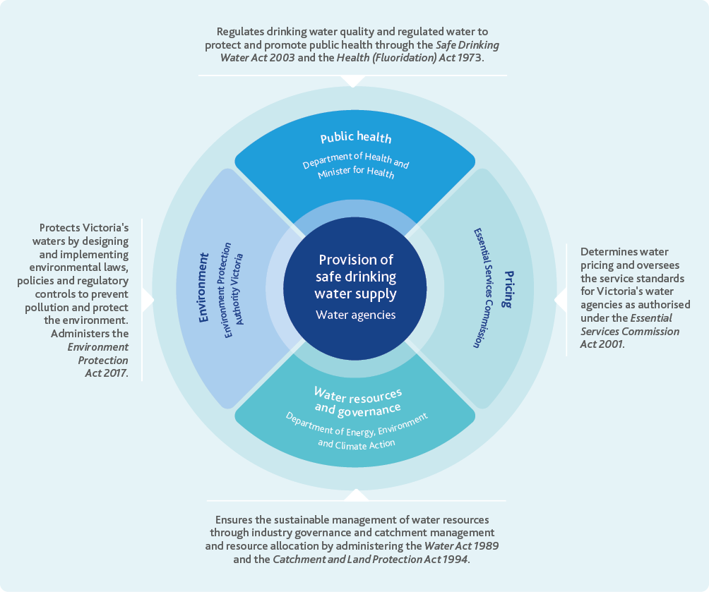

Traditional Owners
At Melbourne Water, we understand the central role water plays in our communities, environment and economy. We also understand that we live and work on the land and waterways that Aboriginal and Torres Strait Islander peoples have lived on, protected, and used for thousands of years, and recognise the intrinsic connection of Traditional Owners to Country.
Melbourne Water considers Traditional Owner organisations, not as customers or stakeholders, but as sovereign partners in land and water management. We aim to build on our existing strong relationships with Traditional Owners by actively developing approaches to support, fund and walk together on Country, such as establishing co-designed partnership agreements detailing how we will work together to achieve mutual outcomes.

Policy directions
Water for Victoria 2016 is the Victorian Government’s statewide plan for water. The plan sets out priority areas for water management across the state and provides a clear strategic direction for the water sector, including in Greater Melbourne. It sets out actions for the water sector so that we are prepared for the likely impacts of population growth, climate change and extreme events on water resources, and highlights the recreational values of water.
The Central and Gippsland Region Sustainable Water Strategy 2022 establishes the Victorian Government’s more detailed plan for sustainable water management in the central and Gippsland region, which includes Greater Melbourne. The Central and Gippsland Region Sustainable Water Strategy recognises the challenges of population growth, and a warmer, drier and more variable climate, and outlines a number of areas for action. These areas include some that relate closely to drinking water quality, such as managing the recreational values of water, and the ongoing transition to greater use of manufactured water – desalinated water for drinking water purposes, and recycled water and treated stormwater for other purposes.
This strategy outlines Melbourne Water’s approach to addressing these Victorian Government policy directions as they relate to drinking water quality.
Fluoridation plants are operated at the direction of the Department of Health to protect dental health. The operation of fluoridation plants is a statutory requirement under the Health (Fluoridation) Act 1973. Only around 0.6 per cent of the water we supply is not fluoridated. This includes several small towns around the eastern edge of Melbourne including Warburton, Yarra Junction, Launching Place, Woori Yallock, Healesville, and Yarra Glen. There are no immediate plans to implement fluoridation in these areas.

How this strategy relates to others
Melbourne Water takes an integrated water management approach to the way we deliver our services. Our strategies are adaptive and linked in the way they explore and address challenges and opportunities across the whole urban water cycle.
This strategy is one of six key strategies that outline how Melbourne Water will deliver its services now and in the future:
- Drinking Water Quality Strategy 2022 (this strategy)
Describes our approach to ensuring we can continue to provide safe, reliable, affordable drinking water over the next 20 to 50 years.
- Greater Melbourne Urban Water System Strategy 2022
Describes how we will work with the retail water corporations to ensure adequate water resources are available to meet water demands across Greater Melbourne over the next 50 years.
- Healthy Waterways Strategy 2018
Sets a long-term, co-designed vision for the rivers, wetlands and estuaries in the Port Phillip and Westernport region.
- Flood Management Strategy 2021
Sets a shared vision and direction for flood management, and outlines how agencies will work together to plan for, avoid and reduce flood risks while supporting emergency preparation and response.
- Melbourne Sewerage Strategy 2018
Outlines how the sewerage system will be managed to enhance and transform its contribution to public health and the environment, and to ensure affordable customer services in a circular economy.
- Regional Catchment Strategy 2022
Sets the plan for how land, water and biodiversity is protected and enhanced across the Port Phillip and Westernport region.
These service strategies reflect Melbourne Water’s vision of enhancing life and liveability and embed the three pillars that underpin Melbourne Water’s vision – healthy people, healthy places and a healthy environment – into the way we do business. These strategies also enable Melbourne Water to articulate how we will deliver the policy objectives established in Water for Victoria, and the Central and Gippsland Region Sustainable Water Strategy.
This Drinking Water Quality Strategy describes how Melbourne Water will continue working with our customers, regulators and stakeholders to optimise management of drinking water quality in the parts of the water supply system we manage. However, the strategy also recognises that our management of drinking water quality in the part of the water supply system we are responsible for fits into a wider catchment to tap approach to managing drinking water quality, delivered in partnership with our customers the retail and regional water corporations. In future reviews, we will work with our customers to determine whether an even more integrated strategy – potentially co-designed – is needed.
Integrated water management
Integrated water management brings together all facets of the water cycle to maximise social, environmental, cultural and economic benefits – it is the way we use water from multiple sources for many purposes to ensure a valued resource goes further. By considering the whole water cycle when planning and delivering services, as well as key interfaces with urban development and broader land and resource management processes, we can take advantage of links between different elements and develop solutions that have broader benefits over a long period of time. The benefits of integrated water management may extend beyond the solution to the initial problem. These benefits can be enabled by coordinated and collaborative planning and management of the water supply system, sewerage system, drainage system and waterways across institutional boundaries through community leaders, Traditional Owners and planners from water corporations, local government, state government, catchment management authorities and other relevant organisations.
Greenvale Reservoir
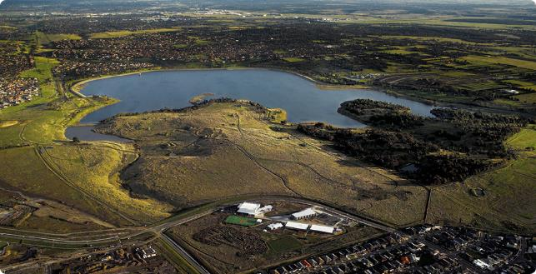


Planning for an uncertain future

Safe, reliable, affordable drinking water in an uncertain future
This strategy provides the framework and direction to ensure we are able to continue to provide safe, reliable and affordable drinking water across Greater Melbourne, even in the face of an uncertain future.
Although we can foresee some potential challenges and opportunities, which this strategy specifically seeks to address, it is likely there will be other challenges and opportunities we cannot predict today.
Melbourne Water will continue to regularly scan and monitor our operating environment throughout the implementation of this strategy to ensure we have time to prepare and adapt our plans to meet new challenges and realise future opportunities.

Increasingly extreme operating conditions
Melbourne’s weather and climate has always been variable, with extended periods of low rainfall causing droughts and periods of high rainfall causing floods.
Both low and high rainfall can be problematic for water quality – potentially for both public health and aesthetic outcomes. This is especially relevant in our protected catchments, where we rely on the performance of our catchments and water storages rather than filtration treatment technology. High winds and floods can also be problematic, disrupting operations of critical water supply assets and the associated infrastructure systems we rely on such as roads, electricity and communication networks etc. A major flood event could overwhelm the capacity of catch drain systems, leading to stormwater flowing into water supply reservoirs.
Compounding this historical variability, Victoria’s climate is changing and will continue to change in the future, becoming drier, warmer and more variable. Beyond the direct impacts on water quantity and quality this will have, it will also increase the frequency and severity of bushfires, which can have immediate and long term impacts on catchment performance and water quality.
For the purposes of this strategy, extreme events are generally defined as events with the potential to significantly disrupt the services we provide. They can be a single isolated event or they can be a set of multiple related or unrelated events that collectively have a significant impact. Climate change and variability are key drivers of extreme events that can impact on drinking water quality, but are not the only drivers. Supply chain disruptions, earthquakes and a pandemic are three examples of other types of extreme events in recent years which have the potential to impact on our ability to manage drinking water quality.

A growing population with changing expectations
Current Victorian Government population projections indicate more than 9 million people may live in Greater Melbourne by 2056 – compared to around 5 million people today. This will lead to substantial growth in water demand. Without intervention, this growth affect the resilience of the water supply system, as our existing water supply assets are increasingly used at their full capacity to maintain normal operations, leaving an increasingly limited margin to manage the impacts of extreme events.
Melbourne’s weather and climate has always been variable, with extended periods of low rainfall causing droughts and periods of high rainfall causing floods.
As the city continues to grow within the urban growth boundary, and as community expectations continue to evolve, we anticipate more people will want to live, work, and play in or near our water supply catchments and other water supply infrastructure. Additionally, we know that Traditional Owners want to connect more with Country in some of these areas. There are challenges and risks related to managing the potential impacts of people wanting to live, work and play in or near our water supply catchments and other water supply infrastructure, but there are also opportunities to explore. An evidence-based approach needs to be taken to assessing the costs and benefits of any additional access to our water supply catchments or other water supply infrastructure, and appropriately manages any water quality, asset integrity and other risks.
We know water affordability is important to the community in the wider context of growing cost of living pressures. Around 51 per cent of people in Melbourne currently feel that the cost of water is ‘about the right price’, but around 37 per cent of people feel that it is ‘too expensive’. In Melbourne, our protected water supply catchments have made a strong contribution to the affordability of water over a long period of time due to the minimal treatment that water from these catchments needs. In terms of operating our existing assets, water sourced from our protected catchments is around 80-90 per cent less expensive to produce than water sourced from our open catchments.
While new technical water quality challenges will continue to emerge, so too will opportunities to manage them.
Managing the challenges, and realising new opportunities described in this strategy, will require substantial investment over the coming years. To minimise any impacts on affordability, without compromising reliability and safety, we will continue to look for innovative solutions that provide the greatest benefit for the lowest cost, taking an integrated water management approach across all our services.
In line with community expectations, the expectations of Melbourne Water’s customers may also change over time. As we respond to climate change and population growth and integrate new sources of water into the system, it will be essential to continue addressing key issues such as how water from different sources is blended in the transfer and distribution systems and how source changes are managed, to ensure the retail and regional water corporations are able to meet the needs and expectations of their customers, the community.

Emerging technical water quality challenges
In addition to the water quality risks we already understand and manage, other challenges may emerge in the future. Examples of the types of challenges we need to prepare for now so that we will be ready to manage them, if and when necessary in the future, include emerging contaminants, microplastics, algae, opportunistic and novel pathogens, and managing a large aging asset base. Our research and monitoring are key to understanding and addressing these types of risks.
In response to scientific knowledge, community expectations change over time, along with government policy directions, regulatory standards. To build preparedness for any changes to regulatory standards, Melbourne Water needs to monitor and stay aligned with industry practice, and more broadly, stay up-to-date with the latest scientific knowledge. This alignment cannot be done in isolation and requires engagement and joint learning with our customers, regulators and stakeholders.
While new technical water quality challenges will continue to emerge, so too will opportunities to manage them. The 1982 water supply strategy for Melbourne noted that ‘distillation is regarded as the only commercially acceptable process for the large-scale desalination of sea water.’ Thirty years later the Victorian Desalination Project was commissioned – a reverse osmosis seawater desalination plant large enough to supply up to around one third of Melbourne’s current water needs. The opportunity to build this asset was enabled by global research and development that made reverse osmosis seawater desalination technology cost effective. We anticipate technology development will continue into the future and we actively invest in research and other initiatives to maximise the benefits that can be derived from future technologies and the enhanced data collection and analysis they may enable.

Supporting environmental sustainability
Managing drinking water quality risks can have environmental impacts, which need to be managed appropriately. For Melbourne Water, environmental sustainability is about acting in a way that ensures future generations have the natural resources available to live an equal, if not better, way of life as current generations and we are committed to this approach in relation to all of our existing and future activities.
Historically, harvesting water from protected catchments high above the city has kept energy consumption relatively low, since this water can be supplied by gravity with minimal pumping (and excess gravitational energy in the water supply network can be harvested as hydroelectricity), and requires only minimal treatment to make it safe. However, this has not been without other impacts on the environment. For example, harvesting this water has disrupted the natural flow regime in the waterways and consequently impacted associated environmental values. Future manufactured water sources are less likely to have a negative impact on waterways – some could even have a positive impact such as by enabling additional environmental flows. However, the treatment required to make water from these sources safe is likely to be very energy intensive and will generate new waste streams that will need to be carefully managed.
Thomson Reservoir
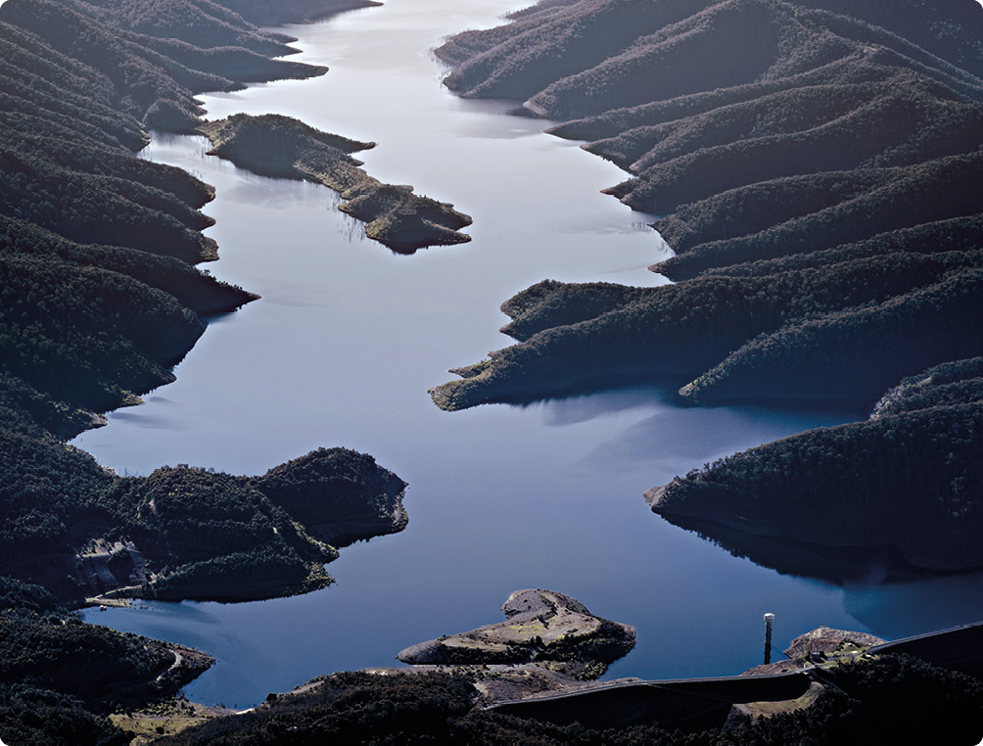


An integrated approach
The challenges faced by Melbourne Water will require us to take a multidisciplinary, collaborative, integrated and adaptive approach to managing drinking water quality into the future. This strategy has been structured around the following strategic objectives:
- Continuity of safe supply
- Source management
- Trust, innovation, and leadership
- Resilience of safe supply
Under each of these strategic goals, we have identified strategic outcomes which characterise what success will look like, and actions that we can deliver in the next five years to drive progress towards the strategic goals. The actions generally relate to new or changed activities. Unless mentioned in an action, existing and planned drinking water quality management activities will continue unchanged.
Actions described under each strategic goal will be further developed through implementation program planning. Each action will then be prioritised and delivered through Melbourne Water’s business planning and capital investment frameworks, with their implementation monitored through the existing reporting processes and governance structures established as part of Melbourne Water’s Drinking Water Quality Management System.
A key focus of this strategy that extends across all four strategic goals is an increasingly collaborative approach to managing drinking water quality from catchment to tap across institutional boundaries. This focus will be reflected as Melbourne Water delivers the actions, through engagement with our customers, stakeholders, and regulators where appropriate, including through existing and potential future industry forums.

How we will know this strategy has been successful
Completion of each action in the strategy is an indicator of implementation progress that can be monitored to determine whether adequate resources have been allocated to strategy implementation. The success of the strategy will also be determined by the extent to which Melbourne Water is able to achieve the following three performance indicators:
- Appropriate catchment management and engineered treatment barriers are in place for all water sources, including to enable routine achievement of 1 microDALY per person per year for microbial risk for all water sources by 2027.
- Regulators and retail water businesses endorse plans for proposed investment related to drinking water quality risk and resilience in the 2026 Price Submission.
- Customer relationship performance indicator scores are maintained and improved for the water service between 2022 and 2027, as measured through the customer satisfaction by service and customer effort metrics for the retail and regional water corporations.
Figure 5. Structure of the integrated approach described in this chapter
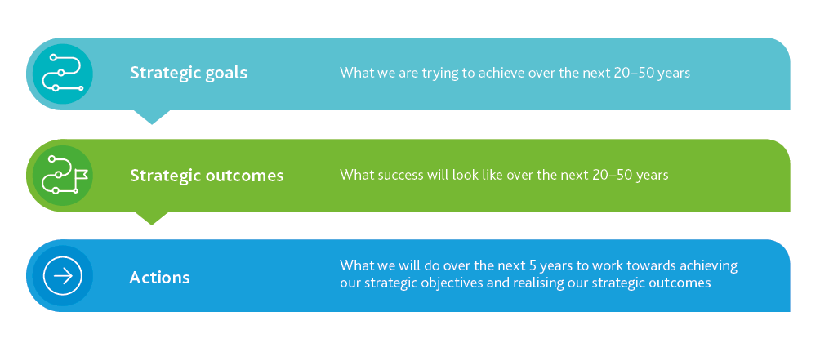

Strategic goal 1: Continuity of safe supply
We continuously improve our systems, processes, people and infrastructure to enable us to do the basics of drinking water quality risk management brilliantly.
Current and emerging drinking water quality risks are quantified, documented, communicated and managed proactively and systematically from catchment to tap in partnership with our customers.
Appropriate management of drinking water quality risks is essential to achieving the vision of this strategy – safe, reliable, and affordable water services. Under the Safe Drinking Water Act 2003, Melbourne Water ‘must:
- prepare a risk management plan in relation to its supply of water to a water supplier; and
- implement the plan and comply with any requirements set out in the plan; and
- keep the plan under continuous review with a view to updating and improving it; and
- revise any aspect of the plan that is found, on review, to need revision.’
To systematically discharge these obligations Melbourne Water relies on a Drinking Water Quality Risk Management System based on ISO9001 Quality Management System requirements and the Hazard Analysis Critical Control Point (HACCP) methodology. This management system is shown in Figure 6.
As part of our commitment to continuous improvement, we have recently delivered a comprehensive external review of our Drinking Water Quality Management System across the 12 elements of the Australian Drinking Water Guidelines.
Through this review, which included benchmarking against local and international industry practice, we have identified opportunities for improvement. These have been captured in our Drinking Water Quality Improvement Plan – our central register of improvement actions – and will be progressively implemented. The actions described in this strategy will also be integrated into our improvement plan, to ensure systematic implementation of the strategy under appropriate and consistent governance arrangements.
At the core of our Drinking Water Quality Management System is our drinking water quality risk register. The purpose of this risk register is to quantify, document, track and communicate all existing and emerging, operational and strategic risks to drinking water quality and the controls that Melbourne Water uses to manage them. During the review of the management system, opportunities to improve the structure of our risk register were identified. Also identified were opportunities to review the specific risks currently captured and to enhance the processes and governance we use to drive risk management actions and continuous improvement.
Melbourne Water is also committed to continue enhancing the interface and alignment between our drinking water quality risk register – and more broadly our Drinking Water Quality Management System – and those of our customers. This will support an increasingly coordinated and systematic catchment to tap approach to managing drinking water quality risks.
Yan Yean water treatment plant
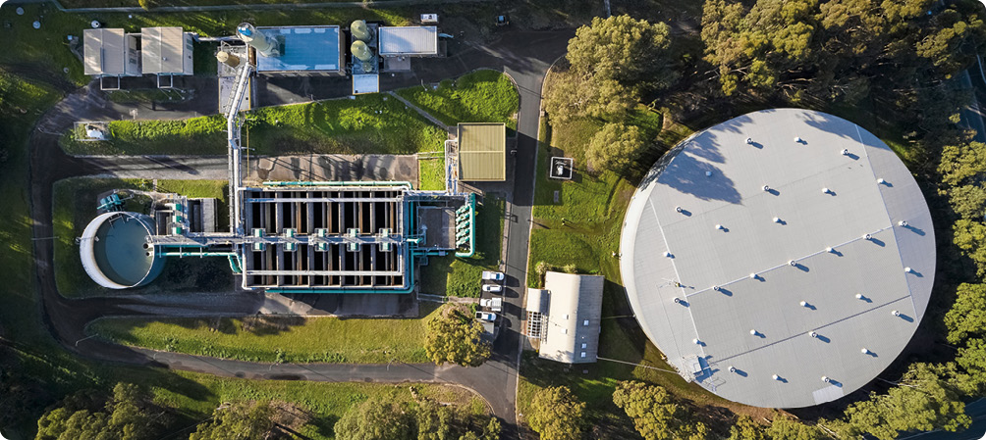
Figure 6. Melbourne Water’s Drinking Water Quality Management System
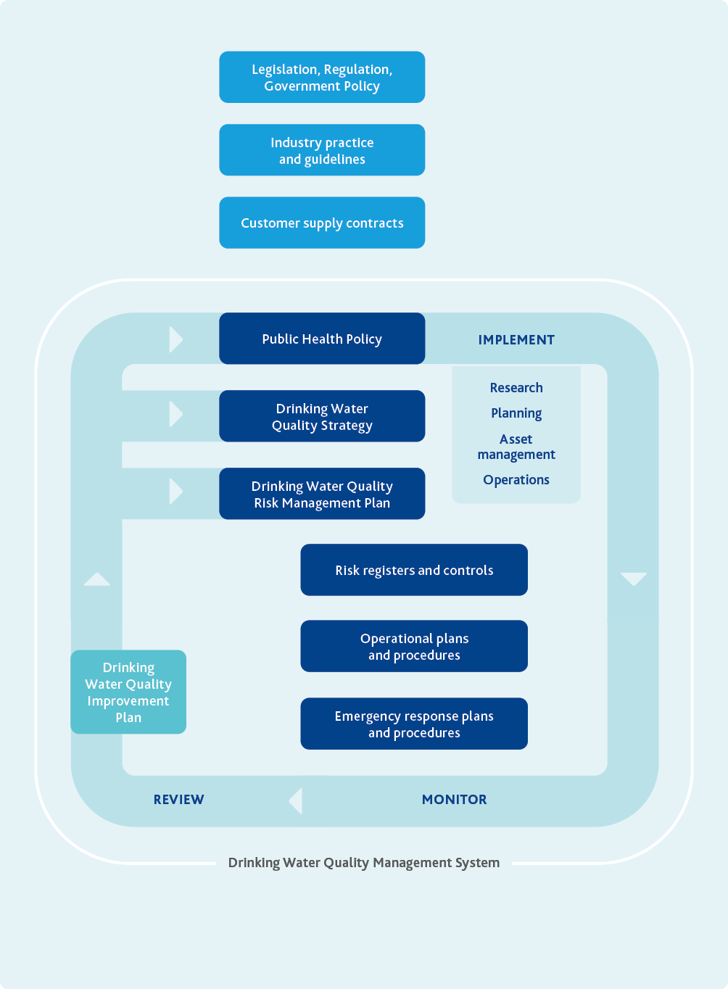

Action
1.1 Keep the Drinking Water Quality Management System aligned with good industry practice:
Prepare a discussion paper by December 2025 that identifies potential lessons we can learn from other industries and activities including nuclear, petrochemicals, aviation, dam safety and major hazard facility management.
Review and restructure the drinking water quality risk register in collaboration with our customers by June 2024.
Align the new risk register and associated business processes to enable effective and consistent risk prioritisation and communication, and guide continuous improvement programs by December 2024.
Commission a comprehensive external review of the Drinking Water Quality Management System once every five years, with the next review to commence in 2026. An overarching objective of the review is to continue working with our customers to drive an increasingly seamless catchment to tap approach to managing drinking water quality.
Result
The Drinking Water Quality Management System discharges relevant legislative and regulatory obligations, reflects good industry practice, drives risk management activities across Melbourne Water and aligns well with the management systems used by our customers to support a catchment to tap approach to managing drinking water quality.
Efficient and effective management of drinking water quality risks is delivered by a diligent, capable, and knowledgeable workforce
Robust systems, processes and assets are essential to efficiently and effectively manage water quality risks but so too are the people who create, manage and operate those systems, processes and assets. The Australian Drinking Water Guidelines note that ‘The knowledge, skills, motivation and commitment of employees and contractors ultimately determine a drinking water supplier’s ability to operate a water supply system successfully. It is vital that awareness, understanding and commitment to performance optimisation and continuous improvement are developed and maintained within the organisation.’
In this strategy, we broadly define the core characteristics needed by our people – at all organisational levels – involved in managing drinking water quality risks as:
- Diligent: Showing care, motivation, conscientiousness and commitment – our people actively identify, take ownership of and fully resolve drinking water quality challenges and improvement opportunities.
- Capable: Having the attributes required for performance – our people have the skills to do the jobs we need them to do.
- Knowledgeable: Having the awareness and knowledge of drinking water quality risk management needed to inform appropriate judgement and action – our people know enough to inform the effective and efficient application of their capability and diligence.
To support development and maintenance of these attributes in our staff, Melbourne Water provides a mix of formal training and knowledge sharing activities – both within Melbourne Water and externally. Training, networking and knowledge sharing supports the continuity and resilience of our services by ensuring our people have the necessary knowledge and capabilities.
The knowledge, skills, motivation and commitment of employees and contractors ultimately determine a drinking water supplier’s ability to operate a water supply system successfully.

Action
1.2 Ensure alignment and engagement in relation to drinking water quality throughout Melbourne Water:
Develop and implement an internal drinking water quality communications and engagement plan by December 2023.
Result
A consistently strong understanding throughout Melbourne Water of the drivers for investment in drinking water quality management, and how the work we do contributes to drinking water quality and public health outcomes.
1.3 Maintain adequate resourcing and appropriate skills and capability to manage drinking water quality:
Develop a drinking water quality resourcing and capability plan by December 2024 and implement through the 2026 Price Submission.
Review and update drinking water quality induction and refresher training requirements by June 2025.
Result
We know what capabilities and experience our people will need in the future, and we have a plan for appropriate resourcing of the drinking water quality function across Melbourne Water.
The value of the existing water supply system is maintained, enhanced and leveraged as we invest to meet future challenges and realise future opportunities
We manage a valuable portfolio of water supply assets that needs to be maintained and preserved for future generations – the replacement cost of the existing water supply system would be many billions of dollars. Many of these assets are very long lived and will continue to play a key role in the water supply system in the future, including to support integration of water from future manufactured water sources. We have some assets that are already over 100 years old that we plan to continue maintaining and using as core elements of the water supply system into the foreseeable future.
Ensuring the ongoing use of existing assets doesn’t impact adversely on water quality or other risks, such as through reduced reliability, requires significant investment in renewals and maintenance. In some cases, renewals and maintenance are needed to maintain the longevity, reliability and existing functionality of assets. In other cases, assets become obsolete, when they can no longer provide the services needed to meet regulatory or contractual obligations, or community expectations. In these cases, partial or complete replacement may be needed.
For example, open aqueducts are a very cost-effective means of transferring large volumes of water over long distances and were the only reasonably practicable option for doing so over 100 years ago when many of our existing aqueducts were originally built. However, they offer very limited protection for water quality, and come with other risks, such as safety risks for people and animals. For these reasons and others, Melbourne Water has started to replace some of its open aqueducts with closed pipelines. Our other remaining open aqueducts will be reviewed as they approach the end of their asset life. Business cases for their replacement will be prepared taking into consideration alternative options, such as closed pipelines, that would eliminate the water quality and safety risks associated with existing open aqueducts.
Our Drinking Water Quality Risk Management System does not exist or function in isolation – it exists within a broader Integrated Management System and interfaces with other business processes and systems, such as our Capital Investment Framework, Asset Management System, Enterprise Risk Framework, among others. Managing these interfaces well is important to ensure drinking water quality risks are appropriately assessed, documented, managed and communicated throughout all of our business activities.
Given the importance of maintaining, enhancing and leveraging our existing water supply system, a key priority is improving the interface between our Drinking Water Quality Management System and our Asset Management System. One way of making this interface work well is the specification of clear, measurable and well documented levels of service for the drinking water quality functionality of all of our water supply assets. Clear levels of service enable targeted monitoring to determine asset management actions needed to keep our assets performing effectively and to enable our drinking water quality objectives to be achieved.
Our overarching service objective for drinking water quality is to supply water at the interface points which, at a minimum, complies with quality standards specified in relevant legislation, regulation, contracts, and industry guidelines for both health and aesthetic objectives across microbial, chemical, physical and radiological categories. For the microbial category, this service objective includes achievement of the microbial health-based target of 1 microDALY per person per year.
Action
1.4 Enhance the links between the Drinking Water Quality Management and Asset Management systems:
Prepare, document and monitor clear levels of service aligned with our obligations and risk appetite for all assets that contribute to drinking water quality outcomes by December 2025.
Result
Improved asset performance monitoring and prioritisation of targeted maintenance, upgrades and renewals to ensure our assets are capable of reliably providing the levels of service needed to support appropriate drinking water quality risk management.
What are health-based targets and why are they useful?
The Australian Drinking Water Guidelines note that the ‘greatest risks to consumers of drinking water are pathogenic microorganisms’ and highlight the need for ‘robust multiple barriers appropriate to the level of potential contamination facing the raw water supply.’ For microbial risks, the Australian Drinking Water Guidelines only specify a single quantitative measure defined as the absence of Escherichia coli in routine samples of treated water. E.coli is a faecal indicator, developed over 100 years ago and used worldwide. It is easy and cheap to use, has led to significant improvements in drinking water safety and continues to be a key risk management tool. However, this faecal indicator has limitations, with low probability of detection and the lag between the actual detection and potential incident. It also doesn’t guarantee the water is safe with regard to viruses or protozoa.
Health-based targets set microbial treatment performance targets for bacteria, viruses and protozoa and the focus is on proactive risk identification and control. Health-based targets are increasingly used locally and internationally to specify the tolerable level of microbial risk, enabling appropriate treatment barriers commensurate with quantified microbial risks emerging from catchments to be designed and operated.
The National Health and Medical Research Council has revised the Australian Drinking Water Guidelines to include a microbial health-based target of 1 microDALY per person per year. This target is consistent with the health-based target recommended by the World Health Organization in their Guidelines for drinking-water quality. This tolerable level of risk is the gastrointestinal disease in the community that can be attributed to drinking water supplied.
Melbourne Water worked with other Australian water utilities through the Water Services Association of Australia to prepare the Manual for the Application of Health-Based Targets for Drinking Water Safety in 2015. This manual describes the approach taken by Melbourne Water, underpinned by the science of quantitative microbial risk assessment, to implementing our microbial health-based target of 1 microDALY per person per year.
The 1 microDALY target is highly health protective. At this level of risk, any impacts on the health of the community are too low to measure directly. Various different estimates of the total community disease burden associated with gastrointestinal illness exist, including because a large proportion of gastrointestinal illness is thought to go unreported. The World Health Organization estimated that in 2019, all diarrhoeal diseases caused around 684 microDALYs per person per year in Australia. The vast difference between this background rate and our health-based target means the achievement of our health-based target can only be measured by monitoring leading indicators of risk and by calculating the adequacy of, and maintaining the performance of, the treatment barriers and catchment protection measures. This is consistent with the Hazard Analysis and Critical Control Point methods that Melbourne Water has been using for over 20 years, rather than relying exclusively on lagging indicators of risk such as the number of faecal indicator organisms in water samples.
Drinking water with a level of microbial risk greater than 1 microDALY per person per year is not necessarily unsafe but it does mean that further management actions can be undertaken to reduce risks. This concept is shown in Figure 7.
In response to the formal adoption of Melbourne Water’s microbial health-based target in the 2017 Drinking Water Quality Strategy, we put in place a number of initiatives to enable us to reduce existing microbial risks to the level of 1 microDALY per person per year. For example, at the Winneke water treatment plant, construction of a new ultraviolet disinfection system is underway to provide additional treatment for protozoa.
Adopting a microbial health-based target is also helpful because it can be readily and consistently applied across all of our water sources including those that we may need in the future. In this way, the microbial health-based target will ensure that water from any water source has the same safety profile, regardless of its origins.
Figure 7. Water safety continuum for drinking water supplies
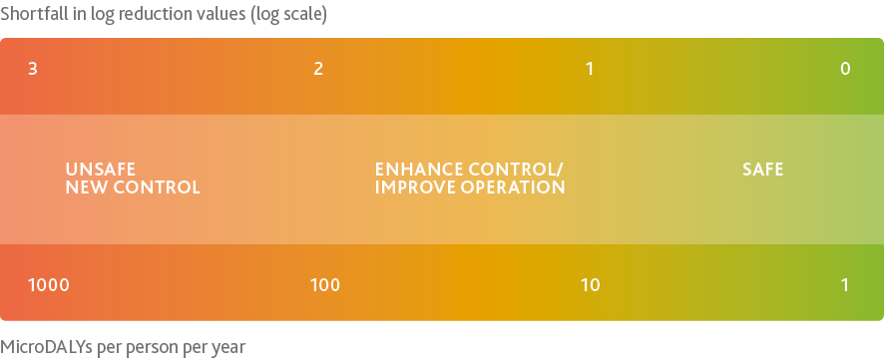

Strategic goal 2: Source management
We take a robust multiple barrier approach to managing drinking water quality risks, ensuring that drinking water from all existing and potential future sources is equally safe.
In protected water supply catchments, drinking water quality risks are managed by chlorine primary disinfection and prudent and efficient investment in bushfire management, unauthorised entry and pest species control programs.
Melbourne Water has a long history of protecting catchments to protect drinking water quality, dating back to the late 1800s when catchment protection was first used to manage public health and aesthetic problems arising from the open Plenty River catchment that was the original water source for Yan Yean Reservoir. Since that time, catchment protection has consistently remained a cornerstone of our approach to managing drinking water quality risks, with over 65 per cent of our water still sourced from protected catchments and subjected to minimal water treatment.
Melbourne’s system of protected catchments provides a significant barrier against contamination from human activities including pathogenic microbes and chemicals. A United States Environmental Protection Agency study of several water supply schemes found the cost of removing contamination by water treatment to be 30 to 40 times that of preventing contamination in the first place. Detention in the major water supply reservoirs further improves water quality before it enters the supply system. As a result, only minimal treatment, chlorine disinfection, pH correction and fluoridation is required to meet physical, chemical and biological water quality standards. This minimal treatment makes water from these sources significantly less costly to produce than it would be if additional treatment was required to manage risks from less well protected catchments.
Protected catchments come with their own challenges and risks. Natural variability in water quality, unauthorised human access, pest animals and plants, and bushfire all pose threats to water quality. These risks must be identified, evaluated and managed through a combination of appropriate treatment and catchment management.
In our recent Catchment Management Optimisation Program, we used economic cost benefit analysis to review the optimal balance of catchment management and treatment options for our water supplies to achieve the microbial health-based target. The program used a participatory approach, drawing in expertise from across Melbourne Water, Parks Victoria and DEECA to understand the cost and effectiveness of possible risk management options.
The Catchment Management Optimisation Program confirmed that for our protected catchments – where we only have chlorine disinfection treatment – continued and increased investment in catchment protection, while maintaining existing treatment, remains the best approach to delivering safe and affordable water. The increased investment in catchment protection currently being implemented targets unauthorised entry, pest plants and animals, and bushfire risk management.
Melbourne Water works closely with DEECA and Parks Victoria to ensure we undertake the right type and extent of catchment management actions in state forests and national parks. We plan to optimise and enhance these interfaces and working arrangements over the next five years.
Two of Melbourne Water’s protected catchments, Yan Yean and Maroondah, supply water via treatment plants with additional treatment to chlorine disinfection. Risks arising from the Yan Yean transfer aqueduct and algae-related issues in the reservoir itself mean that filtration, taste and odour treatment, and ultraviolet disinfection are required. Water from the Maroondah catchment is mixed in Sugarloaf Reservoir with water from the open Mid Yarra catchment (about 45 per cent of the water harvested into Sugarloaf Reservoir was sourced from Maroondah Reservoir over the past 10 years) and therefore requires a higher level of treatment. For these catchments, our Catchment Management Optimisation Program confirmed continued and increased investment in catchment protection, while maintaining existing and planned treatment, remains the best approach to delivering safe and affordable water.
In the developed world, we will soon be the only remaining major city that relies on only chlorine disinfection and protected catchments – everywhere else, additional treatment barriers have already or are currently being implemented. In the future, despite investment in catchment management, we may also need to consider additional treatment barriers and the conditions under which they might be required.
For example, ultraviolet disinfection treatment could be considered as an additional barrier to manage chlorine resistant pathogens if it ceased to be practicable to exclude potential sources of these pathogens from the catchments. For Silvan Reservoir alone, it has been estimated that a new ultraviolet disinfection treatment system is likely to cost more than $240 million to build and around $2–3 million per year to operate.
Alternatively, or additionally, filtration treatment could be considered as an additional barrier to manage chlorine resistant pathogens and would also help to manage potential future algae risks, and variability in colour and turbidity, including following future bushfires. Currently, colour variability is managed by selectively harvesting water from some sources, such as O’Shannassy Reservoir, when colour levels are lower. This selective water harvesting results in lost water harvesting opportunities, some of which could be avoided if filtration treatment was in place at Silvan Reservoir, although filtration would also lead to some new water losses in the substantial sludge waste stream that would need to be managed. For Silvan Reservoir alone, it has been estimated that a filtration plant could cost more than $3 billion to build, and around $50 million per year to operate.
Action
2.1 Continue to partner with DEECA, Parks Victoria, Traditional Owners and other relevant stakeholders to drive continuous improvement of protected catchment management:
Consistent with Melbourne Water’s Reconciliation Action Plan, co-design self-determined partnership agreements with Traditional Owners by November 2023, including consideration of catchment management where appropriate.
Contemporary agreements with Parks Victoria and DEECA are in place by December 2023.
Collaborate with DEECA and Parks Victoria to prepare an evidence-based investment plan by September 2024 for bushfire, unauthorised entry, and pest species management programs for the 2026 regulatory period.
Deliver catchment management programs consistent with the previous Catchment Management Optimisation Program and 2021 Price Determination by June 2026.
Result
Extension and continuous improvement of current and planned catchment management actions to manage bushfire risk and enable achievement of our microbial health-based target.
2.2 Ensure water treatment barriers commensurate with risk over the long term for water sourced from protected catchments:
Develop clear, agreed, evidence-based triggers by December 2026 for adaptive investment in additional treatment barriers for water sourced from our protected catchments.
Result
Leading indicators of risk are adopted that can be monitored to inform the timing and character of any further investment in additional treatment barriers and associated business cases at the Silvan, Cardinia and Greenvale water treatment plants. These leading indicators are underpinned by a shared understanding of the costs, benefits, risks and community willingness to pay associated with potential additional treatment barriers – including in relation to issues that may extend or emerge beyond the boundaries of Melbourne Water’s bulk water supply system.
In open water supply catchments, drinking water safety is ensured through an optimised multiple barrier approach balancing catchment management with engineered treatment barriers
Since the 1980s, Melbourne Water has supplied water from open water supply catchments. Currently Melbourne Water harvests water from two open catchments:
- Sugarloaf Reservoir takes water from the protected Maroondah catchment and the open mid-Yarra catchment
- Tarago Reservoir takes water from the protected Tarago River west branch catchment and the open Tarago River east branch catchment.
Water harvested from these sources is subjected to additional treatment to ensure it is safe and aesthetically acceptable.
The Tarago River east branch catchment includes low density rural residential and mixed agricultural land uses. The mid-Yarra catchment is much larger – at around 140,000 hectares it is nearly as large as all our other catchments combined – and includes a much wider range of land uses, including some suburbs and towns, industrial facilities, mining, mixed agricultural, tourism, and three sewage treatment plants operated by Yarra Valley Water.
The quality of water from protected and open catchments is very different. Figure 8 shows the confluence of the east and west branches of the Tarago River, with cloudy water from the open east branch catchment mixing with relatively clear water from the protected west branch catchment.
For our open catchments, the Catchment Management Optimisation Program confirmed that current and planned levels of investment in catchment management and treatment are already the most cost effective approach to meeting our microbial health-based target.
Even in our open catchments, there are still some important water quality protections in place: recreational access to water storages is minimised, and where allowed, it is within specific conditions such as limited lure-based shoreline fishing, bushwalking and licenced sailing allowed at Sugarloaf Reservoir. This is discussed further in the next section.
Figure 8. Turbid water from the open Tarago River east branch mixing with clear water from the protected Tarago River west branch
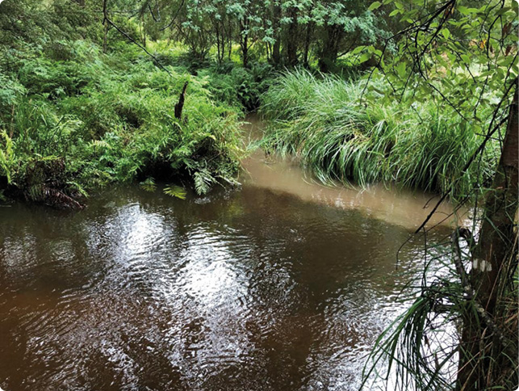
The Tarago catchment is a declared Special Water Supply Catchment Area under the Catchment and Land Protection Act 1994. This makes any development application subject to the Guidelines for planning permit applications in open, potable water supply catchment areas released by the Minister for Water to protect the quality of drinking water supplies, using a risk-based-approach, while facilitating appropriate development within these catchments. In the Tarago catchment, we also have statutory planning controls described in a schedule to the Environmental Significance Overlay, and there is an agreed Catchment Management Plan in place. The planning controls help manage future risk from inappropriate development, while partnership programs established under the Catchment Management Plan with rural landholders and Baw Baw Shire Council, seek to reduce risks from existing land uses. For example, we have worked with the local Landcare group to fence and revegetate drainage lines on private property. Through research in partnership with Monash University, we know that this stock exclusion and revegetation can be effective in improving water quality before it reaches waterways and Tarago Reservoir.
In the much larger, more complex mid-Yarra catchment, we continue to explore options such as requesting it to be declared as a Special Water Supply Catchment Area under the Catchment and Land Protection Act 1994. Extensive development in the mid-Yarra catchment is likely to make planning controls less effective as water quality risk management tools than they are in the less developed Tarago catchment, but they may still play an important role in managing and monitoring future development.
While we continue to explore planning controls, we are also working to develop other programs and relationships that could influence existing land uses and activities in the mid-Yarra catchment. These programs seek to ensure that current water treatment processes remain commensurate with the risks from the catchment, which supports water affordability since implementation of additional treatment processes can be very costly. With the recent merger of Melbourne Water and the Port Phillip and Westernport Catchment Management Authority, we anticipate there will be opportunities to integrate key programs to meet land management and waterway health objectives.
In contrast to our iconic protected catchments, it may not be widely understood in the community that the mid-Yarra catchment is also one of Melbourne’s water supply catchments. In a 2022 survey, when we asked where Melbourne’s water comes from, around 69 per cent of people identified ‘forested water supply catchments and reservoirs’, but only 46 per cent identified ‘rivers and creeks that flow through agricultural areas around the edges of Melbourne’. To underpin the planned agrichemical programs, the potential future declaration of a Special Water Supply Catchment Area, and any other programs we may consider in the future, we plan to develop an overarching communications and engagement program. The purpose of this program will be to inform and educate people who live, work and play in the mid-Yarra catchment and encourage responsible behaviours that could help manage drinking water quality risks without adversely affecting the economic values of the catchment.
In addition to the water quality risks we already understand and manage today, other challenges may emerge in the future, especially in our open water supply catchments where a wide range of human activities occur. Examples include emerging contaminants, microplastics, blue green algae, opportunistic pathogens and antimicrobial resistant and novel pathogens. We need to understand and prepare for these risks and the required additional treatment barriers now so we are ready to manage them over the long term.
In contrast to our iconic protected catchments, it may not be widely understood in the community that the mid-Yarra catchment is also one of Melbourne’s water supply catchments.

Action
2.3 Continue to partner with relevant stakeholders to drive continuous improvement of open catchment management:
Develop and implement a foundational catchment communications and engagement plan by June 2025 for the mid-Yarra catchment that underpins all other subsequent catchment management programs and other potential catchment controls.
Review and update the existing Tarago Catchment Management Plan by December 2024.
Result
Increased community awareness about the mid-Yarra catchment being a water supply catchment and about future programs that target specific risks within the catchment.
2.4 Ensure water treatment barriers commensurate with risk over the long term for water sourced from open catchments:
Develop clear, agreed, evidence-based triggers by December 2026 for adaptive investment in additional treatment barriers for water sourced from our open catchments.
Result
Leading indicators of risk are adopted that can be monitored to inform the timing and character of any further investment in additional treatment barriers at the Winneke and Tarago water treatment plants.
Managing potential risks of per- and poly-fluoroalkyl substances
The Australian Drinking Water Guidelines describe per- and poly-fluoroalkyl substances (PFAS) as a large group of ‘manufactured chemicals that do not occur naturally in the environment’ and ‘are persistent in the environment, show the potential for bioaccumulation and biomagnification, and are toxic in animal studies.’ PFAS have some useful water and heat resistant properties, and have been used widely in consumer, commercial and industrial products. Around the world, PFAS have been detected in air, water, soil and animals.
We have established a risk management framework for emerging contaminants, including PFAS, to ensure we are able to systematically assess and manage any associated risks to human and environmental health.
As part of our assessment of any risks associated with PFAS in drinking water, we have conducted proactive testing in source waters considered more likely to contain PFAS derived from urban or agricultural land uses: mainly in the mid-Yarra catchment. Our other catchments, which generally have a smaller volume and/or range of human activities than the mid-Yarra catchment, are considered likely to have relatively lower concentrations of PFAS. More than 1100 samples were taken and analysed for a range of PFAS during two periods of intensive sampling between 2010-2011 and 2014-2017.
Over 99 per cent of the samples contained no detectable levels of PFAS. For the small number of samples that had detectable levels of PFAS, the maximum concentration was well below the guideline values in the Australian Drinking Water Guidelines.
In Australia, the Australian Drinking Water Guidelines published by the National Health and Medical Research Council provide industry guidance for safe drinking water. Other standards and guidelines exist elsewhere in the world, including some that recommend lower guideline values than those described in the Australian Drinking Water Guidelines. If the guideline values in Australian Drinking Water Guidelines are revised in the future, we will review whether any further risk management actions may be needed.
In the Tarago and Yan Yean water supply catchments, a measured approach to additional recreation is supported when community benefits outweigh costs, where risks can be managed to ensure drinking water safety, and where costs can be appropriately assigned to beneficiaries
In addition to assessing the optimal balance of treatment and catchment management, our Catchment Management Optimisation Program also used an economic cost benefit analysis framework to explore potential options of allowing increased recreational access to water supply catchments and reservoirs. This work was aligned with Victorian Government’s policy directions set out in Water for Victoria, requiring water corporations to ‘consider recreational values when making planning decisions and to prepare land and recreation management plans for all major water storages of recreational value.’
The Central and Gippsland Region Sustainable Water Strategy describes principles for deciding whether to permit water-based recreation at drinking water storages (see below). In considering the extent to which Melbourne Water may be able to support and invest in water-based recreation, we have undertaken or continue to undertake work consistent with these principles.
Principles for deciding whether to permit water-based recreation at drinking water storages
The Central and Gippsland Region Sustainable Water Strategy indicates that:
‘The Victorian Government will apply the following principles when deciding whether to permit water-based recreation at drinking water storages. Permitting access to drinking water storages for water-based recreation will consider where the recreational benefits are the greatest and outweigh the risks and the costs, including to consumers of drinking water. Where the risks and benefits are not clear the precautionary principle will be applied to decision-making: tipping the balance in favour of protecting our drinking water quality in the absence of certainty. New recreational access proposals must articulate:
- which water bodies in the region are currently accessible for recreation, and whether alternative water storages not used for drinking water supply have been exhausted
- the facilities, infrastructure and surveillance programs required to support recreational access in a way that is safe for the public and maximises community benefits
- how risks to drinking water quality and human health have been assessed by water agencies, including against legislative responsibilities and the Australian Drinking Water Guidelines
- the measures necessary to reduce risks to as low as reasonably practicable, including the robustness and reliability of these
- the extent of Traditional Owner support, and any considerations for the protection of cultural values
- the extent of the support of those consumers whose drinking water is supplied by these water storages
- any measures necessary to protect environmental values.
Proposals need to demonstrate how the community will benefit and how consumers of drinking water may be affected, through a robust cost–benefit analysis from the perspective of those using storages for recreation and those of supply customers.
Proposals need to verify that consumers of the drinking water supply have been directly consulted about the risk and ongoing costs to the community.
Proposals must be assessed against obligations under the general environmental duty provisions of the Environment Protection Act 2017, obligations under the Safe Drinking Water Act 2003 for the provision of safe drinking water supply, and any other legislation relating to the protection and security of critical assets and maintaining water quality, and the reliability and quality of water supply.
Investment decisions will ultimately be made on the basis of the above information, where the benefits outweigh the costs and risks to water quality. Cost-sharing arrangements will be agreed as part of the investment decision and will take into account the relative beneficiaries of the project.
Water corporations will report annually on work programs to manage the recreational value of water storages.’
In exploring potential increased recreational access to water supply catchments and reservoirs, Melbourne Water has noted relevant guidance in relation to drinking water quality risks, such as the Australian Drinking Water Guidelines, which indicate that:
‘The greatest risks to consumers of drinking water are pathogenic microorganisms. Protection of water sources and treatment are of paramount importance and must never be compromised.’
‘Prevention of contamination provides greater surety than removal of contaminants by treatment, so the most effective barrier is protection of source waters to the maximum degree practicable.’
Similarly, the World Health Organization recommends:
‘The preferred strategy is a management approach that places the primary emphasis on preventing or reducing the entry of pathogens into water sources and reducing reliance on treatment processes for removal of pathogens.’
Reflecting on this and other relevant guidance from the Australian Drinking Water Guidelines, the Water Services Association of Australia Manual for the Application of Health-Based Targets for Drinking Water Safety notes that:
‘…it is clear that if there is an excess between the treatment requirements implied from the source water assessment and the treatment capability then all reasonable effort should be used to maintain and enhance that excess to the maximum degree practicable.’
‘…the adoption of HBTs should not be used as an excuse to compromise (by accepting degradation of, or actively degrading), the quality of a catchment or raw water source through the introduction of additional pathogen risks to allow those risks to increase to the HBT guideline value.’
Currently, community recreation near Melbourne’s water supply reservoirs is mostly restricted to the adjacent reservoir parks. Anecdotally, these parks were historically considered the ‘jewels in the crown’ of the Melbourne and Metropolitan Board of Works and remain popular recreation destinations today.
All reservoir parks are downstream of reservoirs, so human access does not pose any risk to water quality. The reservoir parks are currently managed by Parks Victoria. This is currently the primary way Melbourne Water discharges its obligation under the Water Act 1989 ‘to provide and maintain facilities for the recreational use of water storages and surrounding areas, where this use is compatible with the protection of a water storage and the other uses to which the water in the water storage may be put.’
Figure 9. The Maroondah Reservoir park below the dam wall has been enjoyed by the community for nearly 100 years
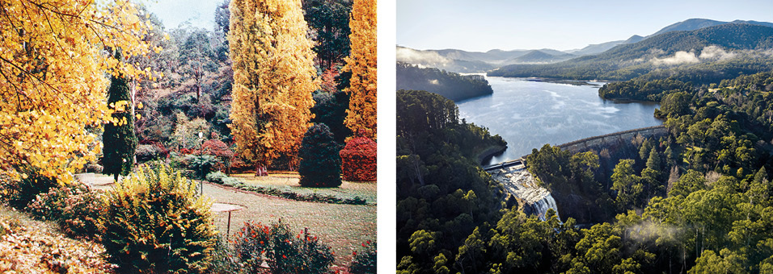
Recreation that involves water contact is currently only allowed at Sugarloaf Reservoir, where licenced sailing can be undertaken. Lure-based shoreline fishing and bushwalking are also permitted at Sugarloaf Reservoir. Sugarloaf Reservoir was historically stocked with brown trout and golden perch. This stocking ceased in 1999 and there are no current plans to start fish stocking again. Key reasons for this include:
- The very poor habitat for fish it provides
- Our obligation under the Water Act 1989 to ‘protect the ecological values of water storages’
- The potential adverse impacts it could have on water quality such as by changing the balance between biology and geochemistry
- The elevated risks of attracting birds (which can carry human infectious pathogens) to prey on the fish
- Some historical concerns around levels of some contaminants in the stocked fish which had no known origins within Sugarloaf Reservoir itself.
As outlined in previous sections, for protected catchments with only chlorine treatment, the results of the Catchment Management Optimisation Program clearly favoured retaining and enhancing existing catchment protection based on overall value to the community. This is due to the very substantial cost to build and operate the treatment that would be needed to manage the increased risks that come with human access. In line with this finding, Melbourne Water does not support recreational access to catchments or reservoirs for any of our water storages with only chlorine treatment.
For water supplies that already have additional filtration and disinfection treatment in place, the results of the Catchment Management Optimisation Program and/or subsequent more detailed investigations suggest that:
Yan Yean Reservoir: The potential community benefits of any additional recreation are likely greater than the costs of implementing additional recreation and managing the associated additional risk to source water quality. On this basis, current information does support Melbourne Water investing in recreation options at Yan Yean Reservoir and we are currently actively investigating a range of potential options for recreation at this site. These ongoing investigations continue to refine our understanding of how each potential option is aligned with the principles described in the Central and Gippsland Region Sustainable Water Strategy. Social research suggests around 45 per cent of Melburnians support Yan Yean Reservoir specifically being opened for public recreation and around 27 per cent oppose it.
Tarago Reservoir: The potential benefits of any additional recreation, including boating and fishing, are outweighed by the costs of implementing additional recreation infrastructure and managing the associated additional risks to source water. On this basis, current information does not support Melbourne Water investing in recreation options. Despite the likelihood that economic benefits would be lower than costs, we do know that the fishing community is interested in Tarago Reservoir, which is home to a self-sustaining population of brown trout. Social research suggests around 44 per cent of Melburnians support Tarago Reservoir specifically being opened for public recreation, and around 27 per cent oppose it. Recreation options at Tarago can be considered further where external funding is provided for capital and ongoing operational costs as well as appropriate measures to protect drinking water quality and fulfil our obligations. Among other measures, an upgrade of Melbourne Water’s ultraviolet disinfection treatment plant would be needed if additional recreation was allowed at Tarago Reservoir.
Sugarloaf Reservoir: The potential benefits of any additional recreation options beyond shoreline fishing, bushwalking and licenced sailing appear to be very limited due to the extensive recreational opportunities that already exist in the surrounding region. On this basis, Melbourne Water does not have any current plans to enable additional recreational access at Sugarloaf Reservoir.
Maroondah Reservoir: The potential benefits of any additional recreation beyond the limited number of existing walking trails and picnic areas in the catchment are outweighed by the costs. For the Maroondah catchment, one of the key issues is the elevated bushfire risk associated with increased human access. This is a particularly important issue in the Maroondah catchment, since any fire started in this catchment is likely to spread into adjacent and nearby water supply catchments for which only chlorine treatment is in place. On this basis, Melbourne Water does not support any additional recreational access at Maroondah Reservoir.
Melbourne Water is currently working with stakeholders to continue exploring potential opportunities for additional recreation at Tarago and Yan Yean reservoirs. Consistency with the principles described in the Central and Gippsland Region Sustainable Water Strategy would need to be clearly demonstrated before implementation of any water based recreation options could commence.
As noted in the Central and Gippsland Region Sustainable Water Strategy, ‘Recreational activities increase the risk to drinking water supplies by introducing contaminants and increasing the potential for outbreaks of waterborne diseases.’ Enabling future additional recreation at Tarago or Yan Yean Reservoir could lead to detrimental short and long term water quality impacts in these waterbodies. Although these impacts can be anticipated, quantified, and proactively managed to some extent, some impacts, particularly over the longer term, may be more difficult to predict. For example, recreational fishing may alter the current balance between biology and geochemistry of the reservoirs by altering the dynamics and behaviours of the standing fish population. This could lead to significant changes in nutrient cycling processes and subsequently trigger problematic algal growth in reservoirs. Appropriate monitoring and adaptive risk management will be key to ensuring effective drinking water quality management over time.
Unusually in the Melbourne water supply system, it is generally possible to completely cease supplying water from the Tarago and Yan Yean water treatment plants, if necessary, without impacting continuity of supply to our customers. Although it would be highly undesirable to miss any opportunities to harvest and use water from either of these sources, being able to temporarily cease supplying water while any unforeseen water quality issues are resolved is a valuable option available to support our adaptive water quality risk management approach.
Action
2.5 Ensure public health and drinking water quality are appropriately protected before any potential future recreation options are implemented at Tarago or Yan Yean Reservoirs to align with Victorian Government policy:
Deliver necessary treatment plant upgrades, catchment management initiatives, and monitoring programs before any additional recreation commences.
Result
Appropriate catchment management and treatment barriers are in place to manage known drinking water quality risks associated with recreation, and adaptive management, and contingency plans are in place to address any other potential risks which may emerge in the future.
Drinking water from future water sources is safe through an optimised, multiple barrier approach balancing catchment management with engineered treatment barriers, enabled by a mature and consistent risk management framework
Analysis undertaken by Melbourne Water for the Central and Gippsland Region Sustainable Water Strategy indicates that by 2070, up to 62 per cent (601 GL per year) of Greater Melbourne’s water needs may need to be provided by new sources of water beyond those available today.
The Central and Gippsland Region Sustainable Water Strategy and Greater Melbourne Urban Water System Strategy both indicate that the volumes available from existing surface water sources around Greater Melbourne are already in decline. The Central and Gippsland Region Sustainable Water Strategy also notes that there are ‘no new large-scale opportunities to extract water sustainably from rivers or groundwater supplies in the region.’ Desalinated water, recycled water and treated stormwater – collectively referred to as manufactured water – appear to be the only available water sources that have the potential to provide the volumes of water likely to be needed in the future.
Desalinated water is the only source of manufactured water currently used as a source of drinking water in Melbourne. Recycled water and treated stormwater are suitable for many non-drinking uses, such as irrigation, subject to appropriate levels of water treatment, and the safe and sustainable use of recycled water and treated stormwater for fit-for-purpose applications will reduce the pressure on our drinking water sources. Melbourne Water will continue to work with our customers to ensure regulation and best practices protect Melbourne’s drinking water supply from the risk of backflow and cross-connection with non-drinking supplies.
We will also engage with DEECA, our customers and other stakeholders to identify, evaluate and implement potential future drinking water supply augmentation options that align with government policy and community expectations. This will include developing an understanding of the potential costs, benefits, risks and risk management options associated with all potential sources of manufactured water, including monitoring the success of initiatives to use treated stormwater and recycled water around the world.
For example, we are currently working with stakeholders and the community to explore options for stormwater harvesting opportunities in key urban growth areas in Melbourne’s north and west. In these areas, there are rapidly closing windows of opportunity to protect the remaining high environmental values in sections of waterways such as Merri Creek and Jacksons Creek by harvesting the large volumes of stormwater that will be generated as the landscape becomes more urbanised. In considering the optimal mix of water sources for Melbourne in the longer term, these sorts of multiple benefits are important considerations to ensure our city remains one of the most liveable in the world.
Melbourne Water is strongly committed to delivering safe, reliable, affordable water, with treatment commensurate with risk for all water sources. Through an optimised multiple barrier approach, balancing catchment management with engineered treatment barriers, we will make all the water we supply in the future just as safe as the water we currently supply by embedding frameworks and targets such as microbial health-based targets now, so they are ready to help manage the increasingly complex and challenging mix of water sources we will have in the future.
Action
2.6 Understand potential water quality challenges and opportunities associated with future sources of water:
Investigate potential target water quality specifications by December 2026 for manufactured water depending on the points at which it could potentially be integrated into the water supply system in the future to ensure public health and drinking water quality are protected.
Result
We have a clear understanding of the potential water quality costs, risks and benefits associated with integrating future manufactured water sources into different parts of the water supply system, and we understand how different water quality parameters may affect those costs, risks and benefits.
Upper Yarra Reservoir
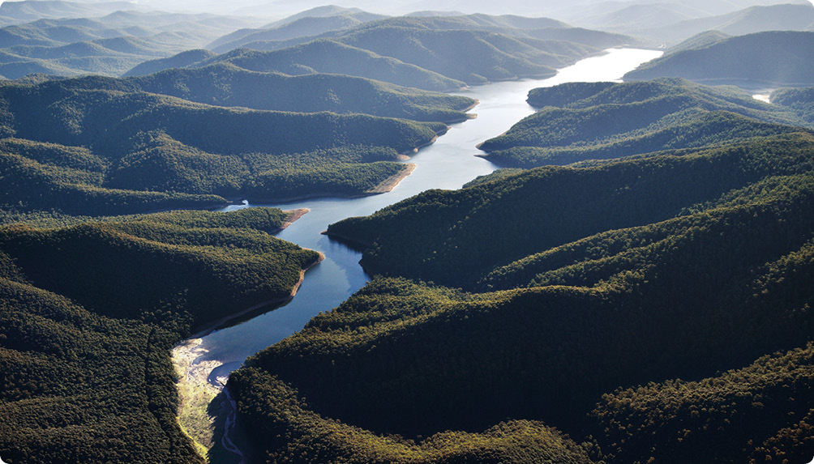
Community perspectives on manufactured water sources
There are a range of community perspectives on the use of desalinated water, recycled water and treated stormwater for drinking purposes. The current levels of support by Melburnians for various potential future sources of drinking water are shown in Figure 10. These preferences were assessed by Melbourne Water for research purposes and are not an indication of current or potential future government policy directions, noting the use of rainwater, stormwater or recycled water as sources of drinking water is not current government policy.
For the purposes of this strategy, we have not differentiated between rainwater collected from roofs and stormwater.
However, Figure 10 does highlight that community perspectives are one area where this simplification may be less valid, since the community feel significantly more positive about rainwater as a potential future source of drinking water than treated stormwater.
Interestingly, although 39 per cent of Melburnians support recycled water being used to contribute to Melbourne’s water supply for drinking purposes, when asked a follow up question worded slightly differently, only 11 per cent of respondents indicated they would be comfortable using recycled water for drinking. This requires further investigation but may suggest that while 39 per cent of people support the concept of recycled water for drinking, a much smaller fraction would actually be comfortable drinking it themselves.
Figure 10. Community perspectives on potential future sources of drinking water
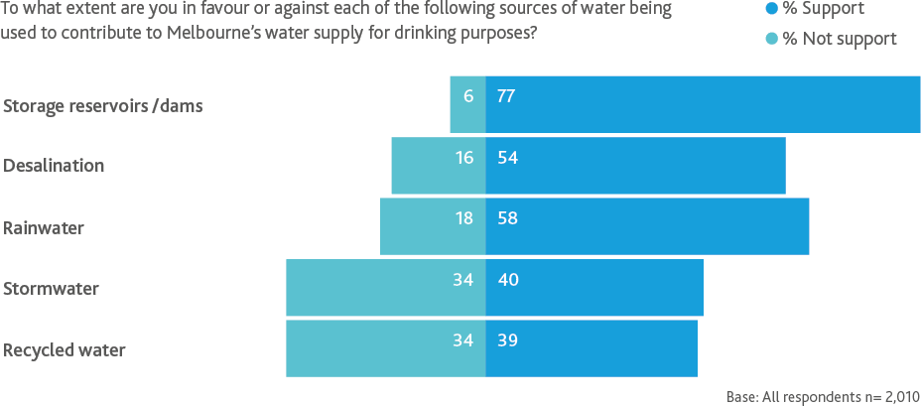

After water treatment, drinking water remains safe as it is transferred to our customers - the retail and regional water corporations
After primary water treatment, water is transferred through large transfer pipelines and service reservoirs to contractual interface points with our customers the retail and regional water corporations. Beyond those interface points, water is transferred to end users in the community through smaller service reservoirs and distribution pipelines managed by the retail and regional water corporations.
In these parts of the water supply system, downstream of primary treatment, there are a number of risks to drinking water quality – in terms of both public health and aesthetic outcomes. In the transfer system managed by Melbourne Water, key risk management actions include keeping pipelines pressurised and service reservoirs sealed, to prevent any contamination from the surrounding environment. To complement this hygiene, we aim to maintain, where reasonably practicable, appropriate residual chlorine concentrations to provide a further barrier to any pathogens in the transfer system, including through secondary booster chlorination at key points in the transfer system.
Water chemistry, including chlorine residuals, can change as water moves through the transfer system to the interface points. Chlorine residuals, for example, are typically higher in some areas of the transfer system than others, for a range of different reasons. Water chemistry can also change as water moves through the distribution system managed by our customers, and again in household plumbing systems. To continue improving our understanding of water chemistry evolution throughout the supply system, we plan to study the extent to which water chemistry may change in the transfer system, considering parameters including pH, chlorine residuals, corrosivity and colour. This study will assess water chemistry in the transfer system in the context of a catchment to tap approach, taking into consideration how water chemistry may continue to change in the distribution system managed by our customers.
Despite residual chlorine concentrations, and regular pipeline and tank cleaning activities, the transfer network we manage is not a sterile environment. Biological activity is ubiquitous in water supply networks and household plumbing systems around the world. While the majority of the microorganisms that live in the transfer system are likely to be benign, there are some opportunistic pathogens which could potentially impact on the health of some immunocompromised people. We are working closely with our customers to continue building our understanding of these emerging issues.
Action
2.7 Understand water chemistry from catchment to tap to inform potential future business cases for investment in reasonably practicable management actions:
Deliver a water chemistry study for the transfer system by June 2025.
Result
A strong foundational understanding of water chemistry from catchment to tap which can be used to support any subsequent business cases for investment in initiatives to further manage water chemistry and any associated biological activity.

Strategic goal 3: Trust, innovation and leadership
Our customers, stakeholders and regulators value and trust our leadership and innovation in managing our drinking water supplies.
The expertise and agreed outcomes expected by our regulators, customers and stakeholders are embedded in our approach to managing drinking water quality risks
The needs and expectations of our customers, stakeholders and regulators are central to everything we do at Melbourne Water. We recognise and value the expertise and perspectives they offer to support the delivery of safe, reliable and affordable drinking water. We also recognise our customers are much more closely connected with the community – our ultimate customers – than we are, and their insights into community preferences can be a very valuable input to our investment programs.
Consistent with all of our activities, we plan to continue working closely with our customers, stakeholders and regulators during the implementation of this strategy, as we develop and deliver our operational and capital investment programs. Improved coordination of our systems, processes, people and assets with those managed by our customers is central to an integrated water management approach and will help address opportunities for improvement identified as part of the recent external review of our Drinking Water Quality Management System.
During the scoping and development of this strategy, we have consulted our customers, regulators and other stakeholders and the feedback we received has influenced the strategic goals, outcomes, actions and key performance indicators. However, the strategy does not generally address the challenges and opportunities that relate specifically and exclusively to the parts of the water supply system managed by our customers. There may be merit in considering an even more integrated approach to developing this strategy in the future, to ensure it comprehensively addresses all challenges and opportunities from catchment to tap.
Tyabb Service Reservoir
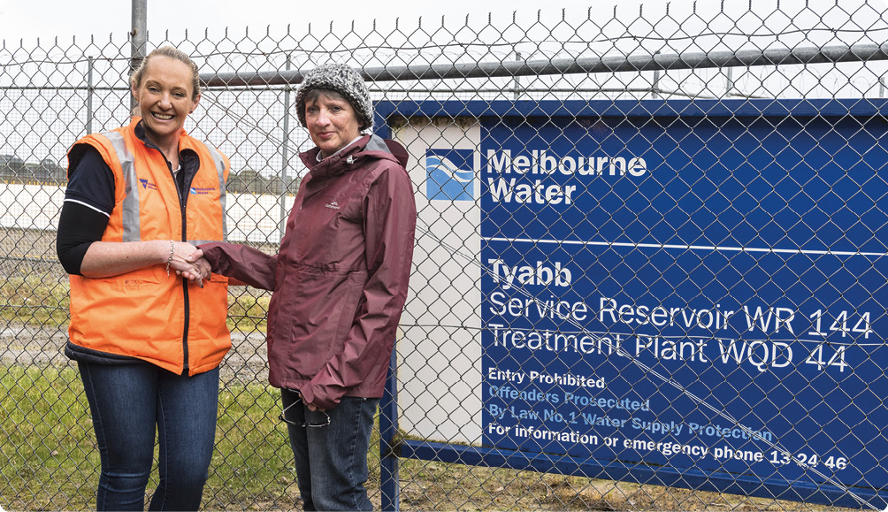

Action
3.1 Set the strategic direction for drinking water quality management from catchment to tap:
Work with the retail and regional water corporations by June 2025 to assess whether the next version of this strategy should be prepared by Melbourne Water or jointly with our customers.
Review this Drinking Water Quality Strategy by December 2027.
Result
An agreed approach to developing the next version of this Drinking Water Quality Strategy to drive an increasingly integrated catchment to tap approach.
3.2 Ensure alignment and engagement in relation to drinking water quality with our customers:
Co-design and implement a structured drinking water quality collaboration plan with our customers – the retail and regional water corporations by December 2023.
Result
Improved collaboration, coordination, relationship building and knowledge sharing in addressing the drinking water quality challenges and opportunities described in this strategy from catchment to tap.
3.3 Support future reviews and development of drinking water quality regulations, guidelines and standards:
Work with the Department of Health and our customers to determine by December 2023 the support needed from the industry for the upcoming review of the Safe Drinking Water Regulations 2015.
Result
The water industry is well positioned to provide evidence-based and data-driven input.
Yan Yean Reservoir
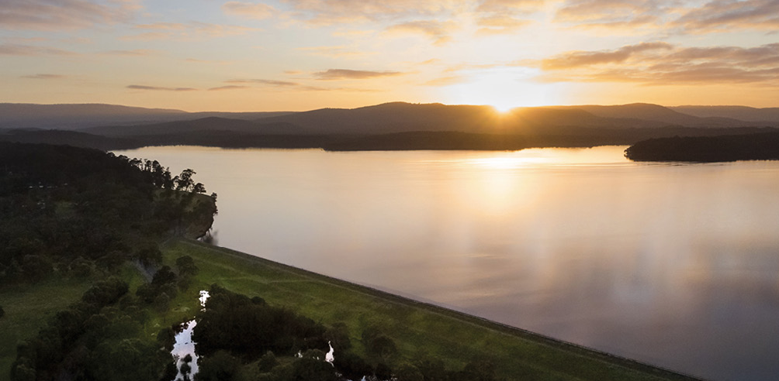
The needs and expectations of our customers, stakeholders and regulators are central to everything we do at Melbourne Water.
Research and monitoring programs build our understanding of water quality issues, identify emerging threats, and provide an evidence base to enable targeted, cost effective and adaptive risk management
In our decision-making, we will reflect regulatory directions, industry guidelines, scientific evidence and benchmarking. We will be transparent in our decision-making and recognise uncertainty. In accordance with risk management standards, we will act proportionately and exercise the precautionary principle where uncertainty may lead to harm or irreversible damage.
To support this approach, research and monitoring are core elements of the Australian Drinking Water Guidelines (Element 5 – Verification of drinking water quality, Element 9 – Research and development). Without a systematically and purposefully curious and inquisitive approach to research and monitoring, it would not be possible to determine what assets to build or how to operate and maintain them effectively and efficiently. More specifically, Melbourne Water’s monitoring and research enables us to:
- Meet legislative obligations and customer expectations
- Foresee, quantify and manage risk including scenario planning as it relates to climate change impacts, fire management and forestry practices
- Facilitate evidence-based decisions in managing water quality risk and defining management regimes and functional requirements
- Remain abreast of relevant national and international trends in public health policy, epidemiology studies and best practice
- Improve our understanding of the nexus between public health and water quality, particularly as it relates to emerging contaminants of concern
- Identify, monitor, and where appropriate, support the development of new technologies that may support drinking water quality risk management
- Inform state, national and international guidelines, regulations and policies that have an impact on water management.
In our research programs, we believe that working with others leads to better outcomes, which is why we partner with other organisations. Collaboration exposes us to new ideas and expertise, both within and outside our industry.
We deliver monitoring programs sometimes as part of research projects and investigations to inform long term planning of the water supply system, but also operationally to demonstrate compliance with our regulatory and contractual obligations and inform short term optimisation of the water supply system.
The evidence base established by our research and monitoring programs is used to enable targeted, cost effective and adaptive risk management – directly supporting provision of safe, reliable and affordable drinking water.
Winneke water treatment plant
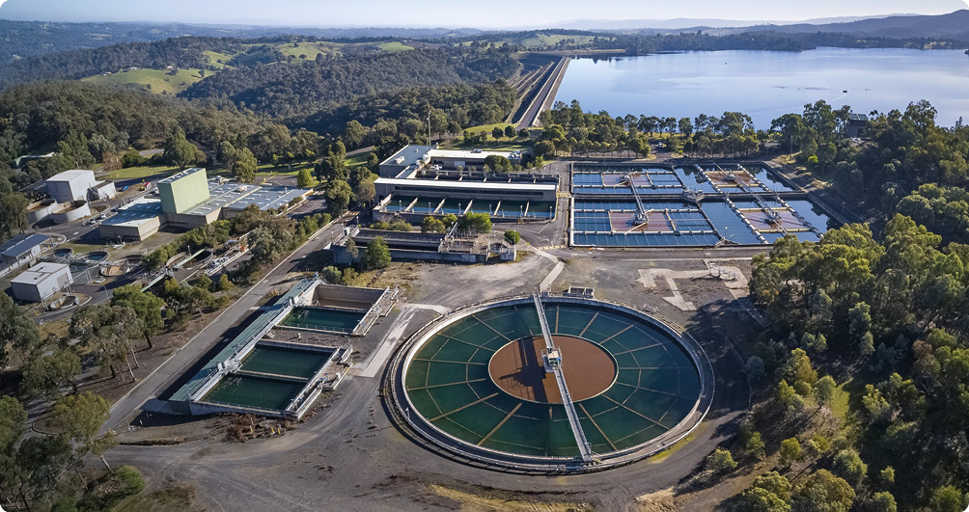
Action
3.4 Deliver a targeted and relevant drinking water research program that delivers value for Melbourne Water and our customers:
Finalise the current comprehensive review of Melbourne Water’s drinking water research program, including consultation with the retail water corporations, and implement the optimised research program by December 2022, with future comprehensive reviews at least once every five years.
Commence by December 2022 further assessments of the feasibility of using eDNA and other techniques to identify the extent of human access to protected catchments.
Commence by June 2023 the development of a predictive operational model for water colour, based on catchment characteristics, to support operational optimisation of sources.
Result
We deliver relevant applied research products which can be used to enhance the effectiveness and efficiency of our activities.
3.5 Drive continuous improvement of our drinking water quality monitoring programs and investigations:
Implement outcomes of the review of drinking water quality monitoring programs currently underway (due to be finalised by December 2022) and undertake further comprehensive reviews of the drinking water quality monitoring programs once every five years.
Result
We continue to collect the right information to inform drinking water quality risk management, including in relation to the challenges and opportunities described in this strategy.
The value of long-term protozoa monitoring in Melbourne’s protected catchments
Melbourne Water sources much of its drinking water from protected and forested catchments. With the emergence of Cryptosporidium as a recognised waterborne pathogen in the early 1990s, Melbourne Water initiated a program to develop a sensitive method to understand any potential risk through faecal scat analysis of native and introduced animals present in the water supply catchment areas.
Over the last 24 years, Melbourne Water, with the University of Melbourne, has collected and analysed more than 11,000 animal faecal samples for protozoa, both Cryptosporidium and Giardia. The extensive dataset has identified an overall low incidence of both protozoa.
The data also demonstrated that although Cryptosporidium is present in approximately 2.2 per cent of scat samples, 99.8 per cent of these detections have been identified as non-human infectious genotypes.
Melbourne Water’s faecal sampling program indicates there are low levels of human infectious protozoa from potential animal sources in the protected catchments supplying Melbourne. This is a key line of evidence that supports Melbourne Water’s decision to continue to defer additional treatment processes for more than 60 per cent of the water we supply.
As a learning organisation, we maximise benefits and minimise costs by adopting innovative approaches and new technologies, and by driving continuous improvement across all our activities
Melbourne Water has a long history of innovation that has underpinned safe, reliable and affordable water services. For example, the protected catchments we continue to benefit from today are an elegant, simple solution to a complex challenge, driven by the innovative thinking of our forebears when faced with the challenges of waterborne disease and poor tasting water sourced from the Plenty River in the 1800s.
To address future challenges and realise new opportunities, the approaches of the past may not always be optimal or even available. As mentioned earlier, the absence of any additional protected water supply catchments from which we can supply more water in the future will drive us to use other water sources that are available. In this environment, innovation is not just desirable – it is essential.
As a learning organisation, Melbourne Water actively foster capabilities, mindsets and habits that support this ongoing need for innovation and constructive evolution. For example, we are currently refreshing our programs to manage unauthorised entry risks in our protected water supply catchments.
The current program involves security patrols, operator surveillance, physical fences and locked gates. The refreshed program, which is being developed by a security specialist, will explore new technologies such as: smart camera technology with image interpretation capabilities; security fencing with sensors that can detect breach attempts; virtual radar fences; autonomous flying drones that can monitor large areas; smart locks that can create a log of authorised entries; de-identified mobile phone location datasets; and other contemporary tools. Trialling and implementing these types of solutions will enable a targeted, effective and affordable security program.
As we continue working to address future challenges and realise new opportunities, we will need to adopt similarly innovative approaches across many different aspects of the water supply system. We want to move towards a future where our activities are increasingly supported by real-time intelligence, remote control and automation, in combination with skilled staff, to ensure our efforts to keep water safe, reliable and affordable are as targeted and effective as possible.
The most effective solutions to water quality challenges may not always be found within the parts of the water supply system Melbourne Water manages – a catchment to tap approach needs to be taken to innovation.
Action
3.6 Structured knowledge brokering with the research community and water industry:
Commission an operating environment scan for drinking water quality, encompassing research and development, and relevant activities of other water utilities around the world once every 2–3 years, with the next due in December 2024 to inform the next update of this strategy.
Result
We are aware of the latest relevant research and development, and share new knowledge and innovations from around the world across Melbourne Water and with our customers.
O’Shannassy Reservoir
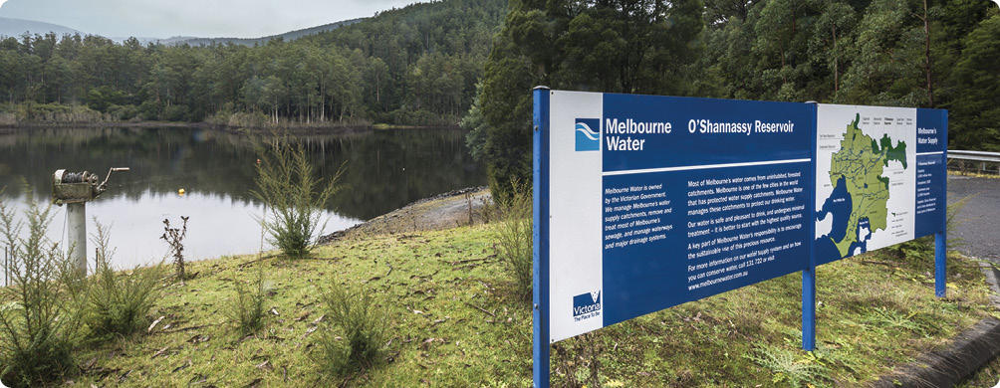

Strategic goal 4: Resilience of safe supply
Potential threats are anticipated, and appropriate measures are in place to enable supply to continue during and after extreme events with minimised impacts on customers.
The water supply system, associated supply chains and related infrastructure systems are resilient to defined and agreed extreme event scenarios associated with climate change and other drivers
Climate change is exacerbating the frequency and severity of extreme events, as observed in the 2019-20 bushfires that impacted much of south-eastern Australia or the 2021–22 catastrophic floods that have devastated Queensland and New South Wales., Bushfires, floods, storms, high winds, algal blooms, pandemics, and other possible extreme events are an ongoing and growing challenge for current infrastructure, supply chains, and associated contingency planning. Extreme events encompass not only isolated events unprecedented in magnitude but also smaller related or unrelated disruptions happening concurrently or sequentially.
Without knowing if and when extreme events can occur, it is important to invest in key initiatives that minimise likely impacts where practicable and to ensure we are well prepared to manage the consequences when a truly extreme, potentially unprecedented event occurs. Low likelihood becomes irrelevant when an extreme event actually occurs and the consequences have the potential to be catastrophic.
‘Resilience’ is a term widely used in society. Although many different definitions exist across multiple different disciplines, resilience is universally considered to be a desirable characteristic that supports good outcomes despite significant adversity. The definition and application of the term calls for articulation of core definitional elements such as resilience of what, resilience to what, and resilience through what and at what costs to whom.
The Intergovernmental Panel on Climate Change defines resilience as:
‘…the capacity of social, economic and ecosystems to cope with a hazardous event or trend or disturbance, responding or reorganising in ways that maintain their essential function, identity and structure as well as biodiversity in case of ecosystems while also maintaining the capacity for adaptation, learning and transformation. Resilience is a positive attribute when it maintains such a capacity for adaptation, learning, and/or transformation.’
According to the United Nations:
‘Over the past decade, building resilience has emerged as an important means to prevent, prepare for, respond to and recover from crises associated with a range of threats to people’s lives, livelihoods and overall sustainable development.’
The World Health Organization has observed that in the literature:
‘…system resilience is defined as the capacity of a system to absorb, adapt, anticipate and transform when exposed to external threats – and/or to forecast shocks that bring about new challenges and opportunities – and still retain control over its remit and pursuit of its primary objectives and functions. Resilient systems develop the capacity to absorb, anticipate or recover from shocks, while adapting and transforming positively their structures and means of operating.’
For the purpose of this strategy, we consider resilience of the whole water supply system as a system-scale characteristic specifically in relation to significant disruptions or shocks such as extreme climatic events or other extreme events that have the potential to impact our ability to supply safe drinking water that is pleasant in appearance, taste and odour. In this way, consideration of resilience is part of our broader risk management approach for a specific class of very low likelihood, very high consequence events.
We define a resilient water supply system as one which, when impacted by extreme events, will be able to maintain, or quickly recover, the system functionality needed to provide water services that meet or exceed regulations, contractual obligations and community expectations. Put simply, a resilient water supply system is able to deliver on the purpose of this strategy to continuously provide safe, reliable and affordable drinking water, in the face of an uncertain and increasingly hazardous future.
The ideas of adaptation and transformation are implicit rather than explicit in this definition. The water supply system may need to be adapted and transformed – or may need to have additional adaptive and transformational capacity – to become truly resilient. Also implied in the definition is our overarching strategic objective in relation to resilience – to provide a seamless customer experience despite extreme events wherever reasonably practicable.
Our conceptual model of system resilience is shown in Figure 11.
Figure 11. A conceptual model of system resilience
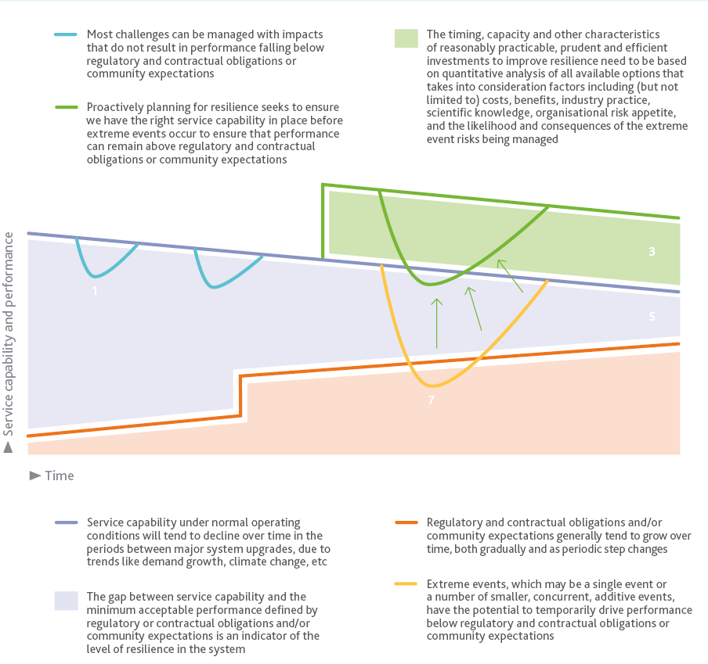
Figure 11 shows several key features of system resilience. The existing water supply system can absorb many of the challenges and disruptions it faces, which are typically moderate to high likelihood events that are well-managed through existing risk management practices.
The existing buffer (the blue region in Figure 11) between service capability and minimum acceptable performance is not fixed in time and is eroded by ongoing trends such as population growth, climate change, growth in community expectations and changing regulatory obligations. A substantial proportion of the existing buffer in the Melbourne water supply system is a legacy of the water efficiency initiatives delivered during the Millennium Drought, which have led to persistent reductions in per capita water demand.
This has created latent capacity in many of our water supply treatment and transfer assets that enables highly valuable flexibility and redundancy that we have relied on to manage extreme events during the past several years. The Victorian Desalination Project is also making a valuable contribution to the existing buffer that we benefit from today.
In the future, if the resilience buffer is allowed to continue to erode, extreme events could drive service capability and performance below the level of minimum acceptable performance in terms of regulatory and contractual obligations and/or community expectations. The solution to this is to proactively explore and quantify the impacts of extreme events scenarios and invest in cost effective interventions well before these and/or other extreme event scenarios occur.
Figure 12. Structured method for assessing and building water supply system resilience
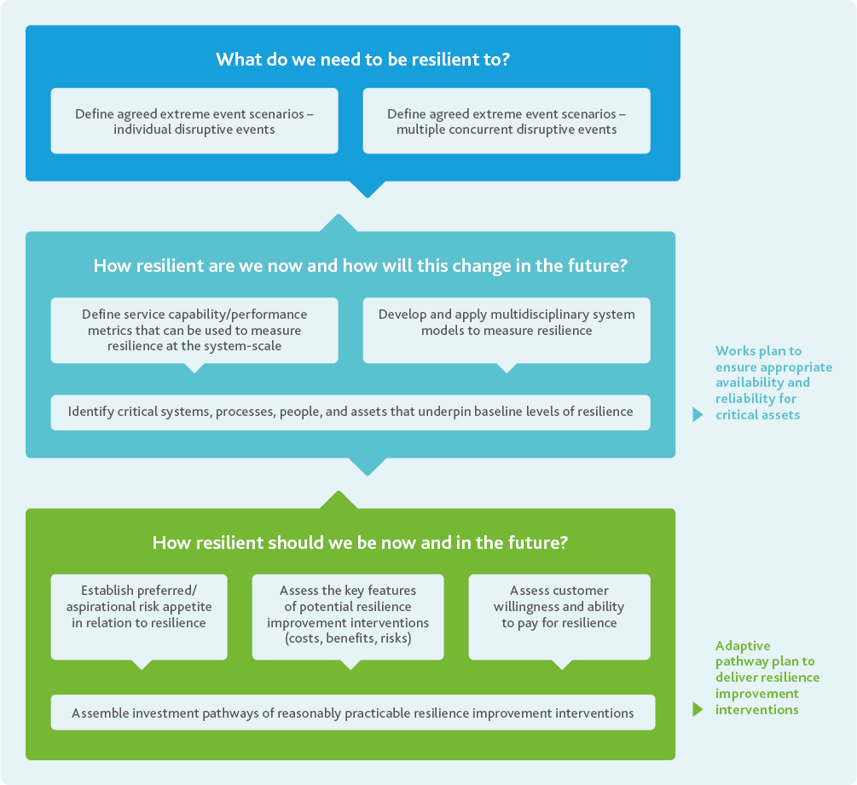
Melbourne Water has been prototyping a structured method for quantifying and building resilience into the water supply system using a hypothetical future bushfire scenario as a case study, shown in Figure 12.
Our water supply system relies on energy, communications and transport infrastructure and many different supply chains. The impacts of extreme events on our water system can be amplified by these interdependencies. We need to be prepared for infrastructure and supply chain failures – working with our customers, stakeholders, regulators and service providers to create resilience in these related systems as well as our own.
This is especially true as we transition to a future where manufactured water will play an increasingly critical role in our water supply system. For example, abundant and secure power supplies and treatment chemical supply chains are essential to the functionality of manufactured water sources, especially if we want manufactured water to be available during and following extreme events to contribute to the resilience of our water supply system. We also need to consider the extent to which resilience relies on our operational staff working in adverse conditions to maintain or repair our assets – it is preferable to proactively design the assets to enable them to continue to operate without intervention, particularly during extreme events.
Deciding what level of resilience is to be pursued is not straightforward and is a function of preferred risk appetite, the options available to improve resilience, and the willingness and ability of customers to pay. Given that all of these factors may change over time, as will levels of resilience, quantifying and building resilience needs to be an ongoing, iterative process.
To determine the appropriate level of resilience, economic cost benefit analysis methods can be helpful. These methods can support the avoidance of undesirable extremes of under-and over-investment, while enabling the development of a sustainable program of prudent and efficient investment.
One approach to ensuring a prudent, efficient investment program is to promote early implementation of interventions that are also required for other purposes such as managing the ongoing impacts of climate change and population growth over the longer term. For example, in the longer term, as noted in the Central and Gippsland Region Sustainable Water Strategy, new water resource augmentations are likely to be required, some of which may present opportunities to enhance the resilience of the water supply system to extreme events. These types of ‘no or low regret’ investments are Integrated Water Management in action, where the solutions to one challenge comes with a range of multiple benefits. It does remain true, however, that even for these types of innovative and efficient solutions, some additional investment is required to achieve additional resilience, which will need to be captured in future submissions to our economic and regulatory partners.
Melbourne Water will continue to quantify and build the resilience of our water supply system to defined extreme event scenarios, and in doing so we will also continue to develop the associated metrics, modelling tools and organisational capabilities. Over time, the impacts of growing water demands and climate change will continue to erode our existing levels of resilience and the resilience available from the potential options outlined above. This means we need to review and adapt our plans on an ongoing basis, continuously identifying and implementing operational and capital options to maintain or improve resilience over the medium to long term.
Action
4.1 Develop and deliver a program of work to build capability and integrate resilience assessment and enhancement into our existing planning and asset management business processes:
Implement the recommendations arising from the previous bushfire resilience investigation, including relevant business cases and investigations.
Develop the set of defined and agreed extreme event scenarios to which we need to be resilient by June 2023, considering our water supply system and the associated infrastructure systems and supply chains we rely on.
Develop a program to measure and enhance resilience to the defined and agreed extreme event scenarios by December 2023.
Result
The set of defined and agreed extreme event scenarios will provide the basis to develop a program of work to measure our current levels of resilience and plan for improved levels of resilience in the future.

Silvan Reservoir
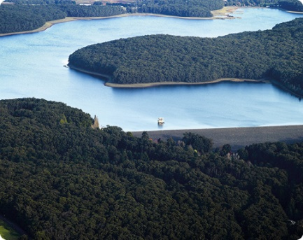
Cardinia Reservoir
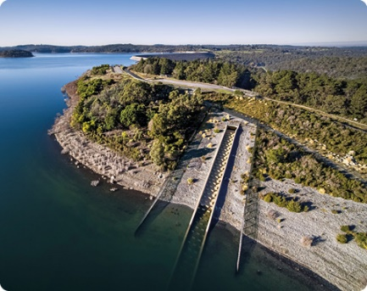

Bushfire resilience
The forested catchments that surround many of our protected water catchments act as natural filters, meaning we can minimise costly water treatment processes and deliver safe drinking water to our customers.
However, relying on protected catchments to defer and/or avoid the need for filtration treatment contributes to increased vulnerability to the potential impacts of bushfires for parts of our water supply system. Bushfires can result in significant water quality risks, the most serious of which are caused by debris flows.
Debris flow is a moving mass of loose mud, sand, soil, rock, water and air that travels down a slope. Debris flows are typically initiated by high intensity (these can be over durations as short as 5-15 minutes), convective rainfall events that occur frequently in south-east Australia following a fire. They can produce sediment loads that are up 1000 times higher than background erosion rates in forested catchments.
A number of programs are already in place to manage this vulnerability in forested catchments. Melbourne Water has a long history of investing in bushfire preparedness and response in partnership with DEECA and Parks Victoria, including a range activities to minimise the risk of major bushfires spreading out of control. We maintain a network of fire access tracks and firebreaks to improve firefighting effectiveness and we perform fuel reduction burns, where appropriate and possible, to minimise the risk of fires taking hold. Under climate change, bushfire risks are set to increase and these bushfire risk management activities will become increasingly important. A recent study found that both frequency and severity of fire weather (‘conditions conducive to fire ignition and spread’) has increased and is expected to continue with each increment of warming. The authors state that, over the last 40 years, the frequency of days with extreme fire weather increased by an average of 56 per cent across Australia.
Melbourne Water employs firefighting crews over the fire season each year to maintain an in-house capability to work with the fire agencies, including first attack fire suppression in our water supply catchments. The crews are strategically located to monitor our catchments and respond quickly to fires as they happen, providing a critical first response capability to reduce the severity and extent of any fires that do break out.
Some areas in the Upper Yarra and Thomson catchments have a high risk of debris flows. A decade of investment by Melbourne Water in post-fire erosion research has led to the development of a quantitative approach to guide debris-flow risk management in these areas. Modelled impacts to water quality post debris flows have shown that water quality issues could last for months in Upper Yarra and Thomson dams, potentially creating severe water shortages for Greater Melbourne. In anticipation, Melbourne Water is actively investing in a range of debris flow mitigation measures including coir log erosion control on upper slopes, debris barriers installed in gully lines and debris racks, drainage risers and enhanced road embankments in lower parts of high risk catchments as illustrated in Figure 13.
Figure 13. Indicative types of debris flow mitigation measures under consideration for high debris flow risk areas
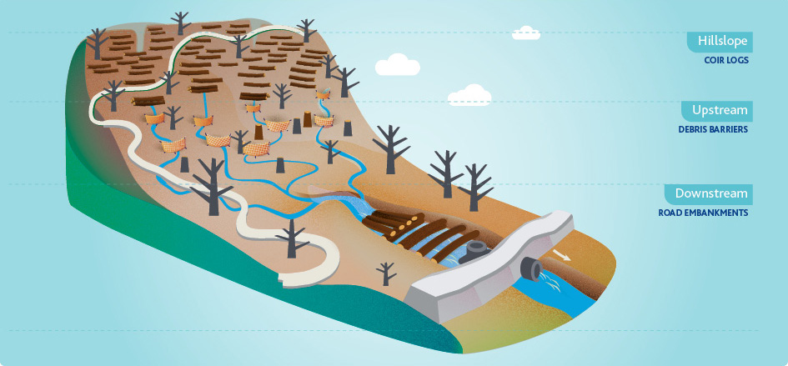
Bushfire resilience continued
The irrefutable increase of the fire season, and more extreme fire weather trends, means that despite our continuous commitment and levels of investment in managing and protecting our forested water supply catchments, bushfires followed by debris flows events remain a key risk for forested catchments.
In 2021, Melbourne Water sought to quantify our current vulnerability to the potential water quality impacts of bushfires, the effectiveness of existing management strategies, and to evaluate potential opportunities for further improvement to make our water supply system more resilient to these types of events.
We investigated the risk of bushfire in our catchments based on historical data and bushfire modelling (using Phoenix Rapidfire software) and quantified the risk of debris flow leading to deterioration of the water quality in the Upper Yarra Reservoir for various bushfire/storm intensity combinations, including the impact of climate change on bushfire risks.
The resilience of the water supply system was measured and expressed as the number of days for which water meeting regulatory and contractual obligations could continue to be supplied to customers following the high turbidity events considered. A water balance model was specifically developed to quantify the immediate and direct impacts as well as the flow-on effects of the scenarios selected.
A number of options were identified that could be packaged together to provide varying levels of resilience while a cost benefit analysis was applied to identify the most cost-effective portfolio of interventions. The findings of this study have informed key initiatives and programs including:
- The proposed upgrade of the Cardinia to Silvan Pump Station capacity and reliability, which is a key priority to enable greater network flexibility and maximise the effectiveness of other operational and capital solutions. This upgrade would likely be needed anyway to support future integration of potential new water resources so it is just bringing forward the investment
- The proposed Winneke-Mitcham Link Main pipeline will reduce key constraints in the network to support flexibility of supply options after bushfires but will also enable increased output from the Winneke water treatment plant at other times by increasing the area that can be supplied by this source
- A review of the capacity, availability and reliability of the Winneke water treatment plant to optimise levels of service for this critical asset
- Maintaining existing operational plans such as keeping a strategic reserve of water in storages downstream of Upper Yarra Reservoir in summer and autumn
- The enhancement and maintenance of relevant contingency plans including exploration of any potential options of temporarily relaxing water quality turbidity and colour standards slightly during emergencies.
Flood resilience
The widespread floods experienced across south-eastern Australia in 2022 are extreme event scenarios which need to be considered.
In our protected catchments, initiatives that enhance the resilience of the water supply system to bushfires in relation to high turbidity issues in particular, would also contribute to enhanced flood resilience. Catch drains are designed to protect water storages from stormwater flows and could become overwhelmed during major floods. These issues could potentially impact Silvan, Cardinia and Greenvale reservoirs which are protected by catch drains.
Floods can also occur in our open water supply catchments, where there are a much wider range of potential sources of contamination, such as sewage treatment facilities and agricultural activities.
In flood conditions, it is possible to stop pumping contaminated flood water into Sugarloaf Reservoir from the Yarra River. It is generally possible to cease supplying water from Yan Yean and Tarago Reservoirs if necessary and rely on substitute supplies of water from other reservoirs across the water supply network – provided supply from those other reservoirs is not impacted by the same flood event.
Similar to bushfires, beyond the direct impacts of floods on our water supply system, there can also be a range of indirect impacts. For example, floods can impact other infrastructure we rely on including transport and electricity networks, and supply chains for chemicals and spare parts.
Action 4.1 in this strategy commits to investigate these issues as part of a wider program to measure and enhance resilience.
Emergency management systems and plans are contemporary and effective, aligned with those of our customers, regulators, and stakeholders, and reflect outcomes of regular emergency management training exercises.
Despite our concerted efforts to manage risk and increase resilience, the possibility of an extreme event or events that exceed the limits of our system remains, and from time to time our system will inevitably have temporary performance issues. In these scenarios, clear, established processes are critical to support emergency management.
At Melbourne Water our emergency management policy guides our approach to managing emergencies. Under this policy, we have a General Emergency Management System based on the Australasian Inter-Service Incident Management System used by emergency management agencies across Australia. This system provides a scalable incident management structure which can be expanded or contracted as an incident increases or decreases in complexity, and flexible procedures and processes which will support a consistent approach to the management of incidents. We have key staff trained and ready to support the roles in our General Emergency Management System and the ability to call on subject matter experts and other support staff as required. This enables us to seamlessly work with other agencies in managing large and/or concurrent emergencies across Victoria. We have also recently worked with our customers to establish the Melbourne Metropolitan Water Industry Response Plan that outlines how we will work together to manage emergencies that extend across institutional boundaries and have the potential to impact large numbers of households.
To support our response to emergencies, we have a series of operational contingency plans that outline ways of minimising risk and maintaining continuity of safe water supply during emergencies. These contingency plans provide emergency escalation pathways and triggers for issues that cannot be managed or where there is uncertainty around effectiveness of actions.
For emergency and contingency plans to remain effective they must be tested and refined. This is something we do regularly through emergency management training exercises and scenarios. For example, in March 2022, 165 people from six water businesses, two Victorian Government departments, Victoria Police, the Australian Water Quality Centre and service provider Ventia came together to test implementation of the Melbourne Metropolitan Water Industry Response Plan with an extreme but plausible emergency scenario. As a result of this exercise, significant improvements have been made to communication protocols to ensure the response plan works effectively and efficiently during potential future emergencies.
Action
4.2 Work with our customers to drive continuous improvement across all our contingency plans for responding to emergencies:
Each contingency plan reviewed and tested on an ongoing rolling review cycle, and structured external review and gap analysis of all contingency plans every five years with the first review delivered by December 2025.
Emergency water restrictions are an element of a number of current water supply contingency plans, but there are some areas of uncertainty around their implementation, so an initial focus will be on working with the retail water corporations to review by December 2024 whether any further work may be needed to enable their rapid and effective implementation if required.
Result
We have contemporary and effective contingency plans in place.
4.3 Deliver a rolling, comprehensive program of emergency management exercises:
Develop a structured program of emergency management exercises by December 2023 including at least one emergency management exercise every year, with diversity in the location and character of the emergency scenarios to enable systematic stress testing of different parts of the water supply system and associated contingency plans.
Result
We have the right people, processes, systems and assets to respond effectively and safely to a range of different emergencies. We provide emergency management exercises and high quality training, support and development to emergency management specialists and general staff who may be called on to assist in major extended duration incidents.
2020 Silvan primary disinfection outage
As a result of a severe storm on 27 August 2020, widespread power outages affected Melbourne Water’s Silvan water treatment plant. The onsite backup generator was able to maintain power to the site before failing late that night, in turn causing intermittent disinfection failure over a period of approximately seven hours. This resulted in approximately 100 ML of non-disinfected water entering the supply network impacting Yarra Valley Water and South East Water customers across 98 suburbs.
The Melbourne Water Incident Management Team worked closely with Yarra Valley Water, South East Water, City West Water, DEECA and the Department of Health on a coordinated response to the incident.
Corrective actions taken included:
- Restoration of emergency power and disinfection processes by approximately 6:30am on 28 August 2020
- Submission of a report to the Department of Health under Section 22 of the Safe Drinking Water Act 2003
- Issuing precautionary boil water advisory notices supported by extensive customer communication through multiple digital and media channels by Yarra Valley Water and South East Water for impacted areas
- Development and implementation of a plan to return to normal operational service in conjunction with retail water corporations
- Targeted chlorine dosing and extensive water quality testing to ensure the water was safe to drink before lifting the boil water advisory notices.
Melbourne Water takes its responsibility for public health extremely seriously. The root causes of the Silvan primary disinfection outages have been investigated, and a program of work to address them and other opportunities for continuous improvement are now being delivered in collaboration with our customers and the Department of Health.
Among other key actions, we are working to deliver the new Mt Evelyn water treatment plant, which was already planned well before the August 2020 Silvan primary disinfection outage. This new primary disinfection plant will be able to treat water supplied from Silvan Reservoir, around 3.5 km downstream of the existing Silvan water treatment plant. It will enable continuity of primary disinfection for the vast majority of water supplied from Silvan Reservoir during future planned and unplanned outages of the existing disinfection plant. The new water treatment plant will also introduce valuable supply chain resilience, since it will use liquid sodium hypochlorite as the source of chlorine rather than the chlorine gas used at the existing Silvan water treatment plant.
Silvan Reservoir
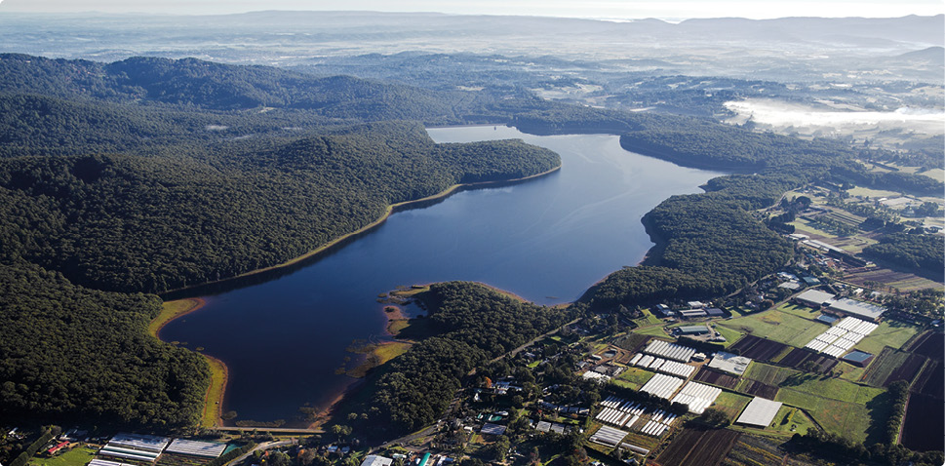
Our customers, regulators and stakeholders share our understanding of potential vulnerabilities to extreme events and support investment decisions that reflect community willingness to pay for enhanced resilience
In managing risk and pursuing resilience, Melbourne Water needs to ensure our approach and investment priorities reflect the needs and expectations of our customers, stakeholders, regulators and ultimately the community. This requires genuine dialogue, where we clearly communicate risk and the vulnerabilities in our system, then listen to and act on the perspectives of all groups.
When we recently asked the community to indicate their preferences regarding two opposing statements about resilience and drinking water quality, we found the community prefers a consistent drinking water quality experience, but that for some people, affordability may be even more important, as shown in
Figure 14.
These responses require further research to understand the implications for our approach and investment priorities but they do highlight there are different, sometimes conflicting perspectives in the community, which will need to be well understood to make the right level of investment in managing risk and building resilience. Equally, it also highlights the need for ongoing water literacy improvement programs to ensure the community fully understands the risks we face so they can contribute to our decision-making from an informed perspective.
Figure 14. Community perspectives about resilience and drinking water quality
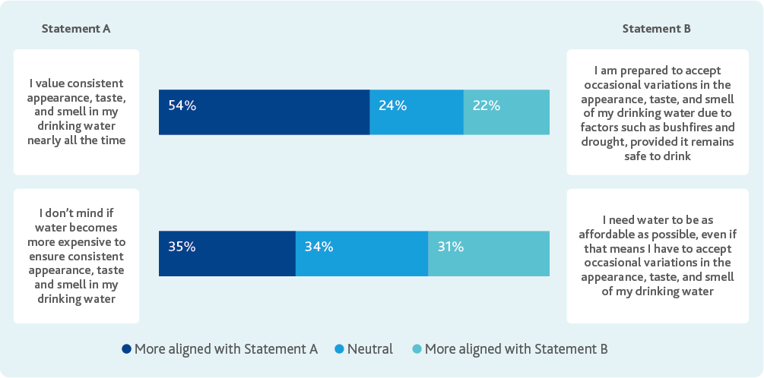
Action
4.4 Understand and reflect customer and community perspectives in our approaches to enhancing resilience:
Develop a program of targeted social research and water literacy improvements by June 2026 to support resilience planning.
Result
We reflect community perspectives in our work to build resilience and we make prudent and efficient investments supported by our customers and the community.


Appendix: Summary of actions
Strategic Goal | Strategic Outcome | Action | Details
Continuity of safe supply | Current and emerging drinking water quality risks are quantified, documented, communicated, and managed proactively and systematically from catchment to tap in partnership with our customers. | 1.1 Keep the Drinking Water Quality Management System aligned with good industry practice. | - Prepare a discussion paper by December 2025 that identifies potential lessons we can learn from other industries and activities including nuclear, petrochemicals, aviation, dam safety and major hazard facility management.  - Review and restructure the drinking water quality risk register in collaboration with our customers by June 2024.  - Align the new risk register and associated business processes to enable effective and consistent risk prioritisation and communication, and guide continuous improvement programs by December 2024.  - Commission a comprehensive external review of the Drinking Water Quality Management System once every five years, with the next review to commence in 2026. An overarching objective of the review is to continue working with our customers to drive an increasingly seamless catchment to tap approach to managing drinking water quality.
Continuity of safe supply | Efficient and effective management of drinking water quality risks is delivered by a diligent, capable and knowledgeable workforce. | 1.2 Ensure alignment and engagement in relation to drinking water quality throughout Melbourne Water. | - Develop and implement an internal drinking water quality communications and engagement plan by December 2023.
Continuity of safe supply | Efficient and effective management of drinking water quality risks is delivered by a diligent, capable and knowledgeable workforce. | 1.3 Maintain adequate resourcing and appropriate skills and capability to manage drinking water quality. | - Develop a drinking water quality resourcing and capability plan by December 2024 and implement through the 2026 Price Submission.  - Review and update drinking water quality induction and refresher training requirements by June 2025.
Continuity of safe supply | The value of the existing water supply system is maintained, enhanced and leveraged as we invest to meet future challenges and realise future opportunities. | 1.4 Enhance the links between the Drinking Water Quality Management and Asset Management systems. | - Prepare, document and monitor clear levels of service aligned with our obligations and risk appetite for all assets that contribute to drinking water quality outcomes by December 2025.
Source management | In protected water supply catchments drinking water quality risks are managed by chlorine primary disinfection and prudent and efficient investment in bushfire management, unauthorised entry and pest species control programs. | 2.1 Continue to partner with DEECA, Parks Victoria, Traditional Owners, and other relevant stakeholders to drive continuous improvement of protected catchment management. | - Consistent with Melbourne Water’s Reconciliation Action Plan, co-design self-determined partnership agreements with Traditional Owners by November 2023, including consideration of catchment management where appropriate.  - Contemporary agreements with Parks Victoria and DEECA are in place by December 2023.  - Collaborate with DEECA and Parks Victoria to prepare an evidence-based investment plan by September 2024 for bushfire, unauthorised entry, and pest species management programs for the 2026 regulatory period.  - Deliver catchment management programs consistent with the previous Catchment Management Optimisation Program and 2021 Price Determination by June 2026.
Source management | In protected water supply catchments drinking water quality risks are managed by chlorine primary disinfection and prudent and efficient investment in bushfire management, unauthorised entry and pest species control programs. | 2.2 Ensure water treatment barriers commensurate with risk over the long term for water sourced from protected catchments. | - Develop clear, agreed, evidence-based triggers by December 2026 for adaptive investment in additional treatment barriers for water sourced from our protected catchments.
Source management | In open water supply catchments, drinking water safety is ensured through an optimised multiple barriers approach balancing catchment management with engineered treatment barriers. | 2.3 Continue to partner with relevant stakeholders to drive continuous improvement of open catchment management. | - Develop and implement a foundational catchment communications and engagement plan by June 2025 for the mid-Yarra catchment that will underpin all other subsequent catchment management programs and other potential catchment controls.  - Review and update the existing Tarago Catchment Management Plan by December 2024.
Source management | In open water supply catchments, drinking water safety is ensured through an optimised multiple barriers approach balancing catchment management with engineered treatment barriers. | 2.4 Ensure water treatment barriers commensurate with risk over the long term for water sourced from open catchments. | - Develop clear, agreed, evidence-based triggers by December 2026 for adaptive investment in additional treatment barriers for water sourced from our open catchments.
Source management | In the Tarago and Yan Yean water supply catchments, a measured approach to additional recreation is supported when community benefits outweigh costs, where risks can be managed to ensure drinking water safety, and where costs can be appropriately assigned to beneficiaries. | 2.5 Ensure public health and drinking water quality are appropriately protected before any potential future recreation options are implemented at Tarago or Yan Yean Reservoirs to align with Victorian Government policy. | - Deliver necessary treatment plant upgrades, catchment management initiatives, and monitoring programs before any additional recreation commences.
Source management | Drinking water from future water sources is safe through an optimised multiple barriers approach balancing catchment management with engineered treatment barriers, enabled by a mature and consistent risk management framework. | 2.6 Understand potential water quality challenges and opportunities associated with future sources of water. | - Investigate potential target water quality specifications by December 2026 for manufactured water depending on the points at which it could potentially need to be integrated into the water supply system in the future to ensure public health and drinking water quality are protected.
Source management | After water treatment, drinking water remains safe as it is transferred to our customers – the retail and regional water corporations. | 2.7 Understand water chemistry from catchment to tap to inform potential future business cases for investment in reasonably practicable management actions. | - Deliver a water chemistry study for the transfer system by June 2025.
Trust, innovation and leadership | The expertise and agreed outcomes expected by our regulators, customers and stakeholders are embedded in our approach to managing drinking water quality risks. | 3.1 Set the strategic direction for drinking water quality management from catchment to tap. | - Work with the retail and regional water corporations by June 2025 to assess whether the next version of this strategy should be prepared by Melbourne Water, or jointly with our customers.  - Review this Drinking Water Quality Strategy by December 2027.
Trust, innovation and leadership | The expertise and agreed outcomes expected by our regulators, customers and stakeholders are embedded in our approach to managing drinking water quality risks. | 3.2 Ensure alignment and engagement in relation to drinking water quality with our customers. | - Co-design and implement a structured drinking water quality collaboration plan with our customers – the retail and regional water corporations by December 2023.
Trust, innovation and leadership | The expertise and agreed outcomes expected by our regulators, customers and stakeholders are embedded in our approach to managing drinking water quality risks. | 3.3 Support future reviews and development of drinking water quality regulations, guidelines and standards. | - Work with Department of Health and our customers to determine by December 2023 the support needed from the industry for the upcoming review of the Safe Drinking Water Regulations 2015.
Trust, innovation and leadership continued | Research and monitoring programs build our understanding of water quality issues, identify emerging threats, and provide an evidence base to enable targeted, cost effective and adaptive risk management. | 3.4 Deliver a targeted and relevant drinking water research program that delivers value for Melbourne Water and our customers. | - Finalise the current comprehensive review of Melbourne Water’s drinking water research program, including consultation of the retail water corporations, and implement the optimised research program by December 2022, with future comprehensive reviews at least once every five years.  - Commence by December 2022 further assessments of the feasibility of using eDNA and other techniques to identify the extent of human access to protected catchments.  - Commence by June 2023 the development of a predictive operational model for water colour, based on catchment characteristics, to support operational optimisation of sources.
Trust, innovation and leadership continued | Research and monitoring programs build our understanding of water quality issues, identify emerging threats, and provide an evidence base to enable targeted, cost effective and adaptive risk management. | 3.5 Drive continuous improvement of our drinking water quality monitoring programs and investigations. | - Implement outcomes of the review of drinking water quality monitoring programs currently underway (due to be finalised by December 2022), and undertake further comprehensive reviews of the drinking water quality monitoring programs once every five years.
Trust, innovation and leadership continued | As a learning organisation, we maximise benefits and minimise costs by adopting innovative approaches and new technologies, and by driving continuous improvement across all our activities. | 3.6 Structured knowledge broking with the research community and water industry. | - Commission an operating environment scan for drinking water quality, encompassing research and development, and relevant activities of other water utilities around the world once every 2–3 years, with the next due in December 2024 to inform the next update of this strategy.
Resilience of safe supply | The water supply system, associated supply chains and related infrastructure systems are resilient to defined and agreed extreme event scenarios associated with climate change and other drivers. | 4.1 Develop and deliver a program of work to build capability and integrate resilience assessment and enhancement into our existing planning and asset management business processes. | - Implement the recommendations arising from the previous bushfire resilience investigation, including relevant business cases and investigation.  - Develop the set of defined and agreed extreme event scenarios to which we need to be resilient by June 2023, considering our water supply system, and the associated infrastructure systems and supply chains we rely on.  - Develop a program to measure and enhance resilience to the defined and agreed extreme event scenarios by December 2023.
Resilience of safe supply | Emergency management systems and plans are contemporary and effective, aligned with those of our customers, regulators and stakeholders, and reflect outcomes of regular emergency management training exercises. | 4.2 Work with our customers to drive continuous improvement across all our contingency plans for responding to emergencies. | - Each contingency plan reviewed and tested on an ongoing rolling review cycle, and structured external review and gap analysis of all contingency plans every five years with the first review delivered by December 2025.  - Emergency water restrictions are an element of a number of current water supply contingency plans, but there are some areas of uncertainty around their implementation, so an initial focus will be on working with the retail water corporations to review by December 2024 whether any further work may be needed to enable their rapid and effective implementation if required.
Resilience of safe supply | Emergency management systems and plans are contemporary and effective, aligned with those of our customers, regulators and stakeholders, and reflect outcomes of regular emergency management training exercises. | 4.3 Deliver a rolling, comprehensive program of emergency management exercises. | - Develop a structured program of emergency management exercises by December 2023, including at least one emergency management exercise every year, with diversity in the location and character of the emergency scenarios to enable systematic stress testing of different parts of the water supply system and associated contingency plans.
Resilience of safe supply | Our customers, regulators and stakeholders share our understanding of potential vulnerabilities to extreme events, and support investment decisions that reflect community willingness to pay for enhanced resilience. | 4.4 Understand and reflect customer and community perspectives in our approaches to enhancing resilience. | - Develop a program of targeted social research and water literacy improvements by June 2026 to support resilience planning.

978-1-921603-45-7 (Print)
978-1-921603-46-4 (PDF)
© Copyright April 2023 Melbourne Water Corporation.
All rights reserved.
No part of the document may be reproduced, stored in a retrieval system, photocopied or otherwise dealt with without prior written permission of Melbourne Water Corporation.
Disclaimer: This publication may be of assistance to you but Melbourne Water and its employees do not guarantee that the publication is without flaw of any kind or is wholly appropriate for your particular purposes and therefore disclaims all liability for any error, loss or other consequence which may arise from you relying on any information in this publication.
All actions in this strategy will be delivered subject to funding.
Melbourne Water
990 La Trobe Street, Docklands, Vic 3008
PO Box 4342 Melbourne Victoria 3001
Telephone 131 722 Facsimile 03 9600 1192
melbournewater.com.au

Resolution 64/292, July 2010.
World Health Organization, 2022 Guidelines for drinking-water quality: fourth edition incorporating the first and second addenda.
Australian Government National Health and Medical Research Council, 2011 Australian Drinking Water Guidelines 6 Version 3.7, Updated January 2022.
Ferriman, A, 2007, BMJ readers choose the “sanitary revolution” as greatest medical advance since 1840, British Medical Journal, 2007, 334:111
Dingle, T and Rasmussen, C, 1991, Vital Connections – Melbourne and its Board of Works 1891-1991, Melbourne and Metropolitan Board of Works.
National Health and Medical Research Council (NHMRC), National Resource Management Ministerial Council (NRMMC), 2011, Australian Drinking Water Guidelines, Paper 6 National Water Quality Management Strategy. NHMRC, , NRMMC, Commonwealth of Australia, Canberra.
Water Research Australia, 2021, Waterborne disease outbreaks are unacceptable, Healthstream, Issue 102 July 2021, WRA.
Melbourne Water, 2022, Water Issues Research, Melbourne Water.
National Health and Medical Research Council (NHMRC), National Resource Management Ministerial Council (NRMMC), 2011, Australian Drinking Water Guidelines, Paper 6 National Water Quality Management Strategy. NHMRC, NRMMC, Commonwealth of Australia, Canberra.
Infrastructure Victoria, 2021, Victoria’s Infrastructure Strategy 2021-2051, Infrastructure Victoria.
Water Services Association of Australia, 2019, All Options On The Table – Lessons from the Journeys of Others, WSAA
Modified after Department of Health, 2022, Annual report on drinking water quality in Victoria 2020–21, State of Victoria, DH.
Department of Environment, Land, Water and Planning (DELWP), 2019, Victoria in Future 2019, DELWP.
Melbourne Water, 2022, Water Issues Research, Melbourne Water.
Melbourne and Metropolitan Board of Works, 1982, A Water Supply Strategy for Melbourne – Planning for an Uncertain Future, Melbourne and Metropolitan Board of Works.
Melbourne Water, 2022, Environmental Sustainability Policy, Melbourne Water
National Health and Medical Research Council (NHMRC), National Resource Management Ministerial Council (NRMMC), 2011, Australian Drinking Water Guidelines Paper 6 National Water Quality Management Strategy, NHMRC, NRMMC, Commonwealth of Australia, Canberra.
World Health Organization, 2020, Global Health Estimates 2020: Disease burden by Cause, Age, Sex, by Country and by Region, 2000-2019, Geneva, World Health Organization.
Modified after National Health and Medical Research Council (NHMRC), National Resource Management Ministerial Council (NRMMC), 2011, Australian Drinking Water Guidelines, Paper 6 National Water Quality Management Strategy. NHMRC, NRMMC, Commonwealth of Australia, Canberra.
United States Environment Protection Agency (US EPA), 1995, Benefits and costs of prevention: Case studies of community wellhead protection, Vol 1, Source water protection business and economic series report No.2, US EPA.
Sargent, T, 2020, Assessing the effectiveness of vegetated stream buffers for improving the quality of runoff from agricultural land, PhD Thesis, Monash University.
Melbourne Water, 2022, Water Issues Research, Melbourne Water.
National Health and Medical Research Council (NHMRC), National Resource Management Ministerial Council (NRMMC),2011, Australian Drinking Water Guidelines Paper 6 National Water Quality Management Strategy, NHMRC, NRMMC, Commonwealth of Australia, Canberra.
World Health Organization, 2022, Guidelines for drinking-water quality: fourth edition incorporating the first and second addenda, World Health Organization.
Water Services Association of Australia (WSAA), 2015, Manual for the Application of Health-Based Targets for Drinking Water Safety, WSAA.
Melbourne Water, 2020, Where To, 2020 Community Recreation Research Report, Melbourne Water.
Melbourne Water, 2020, Where To, 2020 Community Recreation Research Report, Melbourne Water.
State of Victoria, 2022, Central and Gippsland Region Sustainable Water Strategy
Melbourne Water, 2022, Water Issues Research, Melbourne Water.
For further detail see Haydon et al. 2022. “24 years of Cryptosporidium monitoring and research in the Melbourne water supply system”. OzWater 2022
Commonwealth of Australia, October 2020, Royal Commission into National Natural Disaster Arrangements Report, Commonwealth of Australia.
Climate Council of Australia, 2022, A Supercharged Climate: Rain Bombs, Flash Flooding and Destruction, Climate Council of Australia.
Intergovernmental Panel on Climate Change (IPCC), 2022, Climate Change 2022 Impacts, Adaptation and Vulnerability Summary for Policymakers, IPCC.
United Nations, 2020, UN Common Guidance on Helping Build Resilient Societies, United Nations.
World Health Organization, 2017, Strengthening resilience: a priority shared by Health 2020 and the Sustainable Development Goals, World Health Organization.
M. Jones et al.,2022, Global and regional trends and drivers of fire under climate change, Reviews of Geophysics.
Melbourne Water, 2022, Water Issues Research, Melbourne Water

